Influence of nano edible coating & films combined with zinc oxide and active phenol compounds from pomegranate peel to prolong shelf life of minimally processed pomegranate

Hosam El din Aboul anean^{1,}*, Dina M. D. Bader ², N.S. Abd EL-Gawaad ³ , Heba A. Shaat ⁴, M. Al-Dossari ⁵ and L. O. Mallasi⁶*
¹ Food Engineering and Packaging Department, Food Technology Research Institute (FTRI), Agriculture Research Center (ARC), Giza 12619, Egypt; Hosam. ftri@yahoo.com
² Chemistry Department, Muhayil College of Science and Arts, King Khalid University, Abha 1421, Saudi Arabia; ddeyaa@kku.edu.sa
³ Department of Physics, Faculty of Science, King Khalid University, Abha 62529, Saudi Arabia; Nshat@kku.edu.sa
⁴ Food Science and Technology Department, Faculty of Home Economics, Al-Azhar University, Tanta 31732, Egypt; heba.shaat@yahoo.com
⁵ Department of Physics, Faculty of Science, King Khalid University, Abha 62529, Saudi Arabia mdosri@kku.edu.sa
⁶ Department of Home Economics, Faculty of Science and Arts Muhayil Aseer, King Khalid University,Abha 1421, Saudi Arabia; lohosain@kku.edu.sa
*Correspondence: Hosam. ftri@yahoo.com And L. O. Mallasi lohosain@kku.edu.sa.; Tel.: +20-011 1266 7765 or +20-010 1884 2643-+966552324929 ; Fax: +20-35684699.

Abstract: Edible coating and film from chitosan and incorporating it with the action of ZnONPs on active phenol compounds from extracts of pomegranate peel (PPE). The physical and chemical properties of edible films made with zinc oxide ZnONPs and active phenol compounds extracted from pomegranate peel (PPE) were studied.
Adding ZnONPs with active phenol compounds from extracted pomegranate peel (PPE) to chitosan films can provide safe edible films, decrease microbial growth, consequently prolong the shelf life of pomegranates, and improve the physiochemical stability of the pomegranate.
The substances used in this experiment were film with a (A) extract of pomegranate peels (PPE), 5% (0.1%), (B)ZnONPs 1% (0.02%), (C) ZnONPs 2% (0.04%), (D) ZnONPs 3% (0.06%), (E) ZnONPs 1%/PPE1% (0.02%), (F) ZnONPs 2%/PPE2% (0.04%), (G) ZnONPs 3%/PPE3% (0.06%) wt% of chitosan on quality attributes and prolonging the shelf life of pomegranates were stored in plastic containers at 2 °C and 90–95% relative humidity for 20 days.
The treatments of (G) ZnONPs 3%/PPE3% (0.06%) loaded on chitosan as well as chitosan and (D) ZnONPs 3% (0.06%) reduced the weight loss, had excellent microbial counts until 20 days of storage, and recorded the lowest microbial count and mould & yeast colonies.
Other chemical properties studied included total soluble solids content, acidity, anthocyanin content, firmness, and ascorbic acid. Results indicated that ZnONPs 3%/PPE3% (0.06%) loaded on chitosan or ZnONPs 3% (0.06%) were the best treatments for preserving pomegranate arils. It was found that the best measurements were that the film-forming nanoemulsion solutions decreased by E = 110 nm and B = 134 nm. Nano-edibles followed treatment, at F% 188.7 nm, compared to nano-edible films, which were A0% 1312 nm.
Keywords: chitosan; ZnONP; pomegranate; mechanical; viscosity; vapor; zeta particle size; color; light transmittance; scanning electron microscopy and Nano-edible Coatings and Films.

1. Introduction
Polysaccharide-based edible coatings and their derivatives are widely used to fabricate edible coatings and films to enhance food products’ shelf life and quality retention. They are proven to possess good oxygen barrier properties but are hydrophilic; edible coatings derived from polysaccharides lack good moisture barrier properties. Polysaccharide-based edible coatings are colourless and have a lower caloric content. In addition, it can be used to extend the shelf life of food products such as fruits and vegetables.
Chitosan is a partially deacetylated polymer of acetylglucosamine, which is a naturally occurring linear cationic polysaccharide. Chitosan is obtained through the alkaline deacetylation of chitin, which can be extracted from various crustacean shells, fungal cell walls, and other biological materials. The antimicrobial activity of chitosan depends on its concentration, molecular weight, and deacetylation degree. Chitosan solutions in various organic acids can be prepared, which form flexible, transparent, and rigid films that are suitable oxygen barriers upon drying. In the food industry, chitosan has been extensively used for direct surface coating of meat and fruit products to reduce food deterioration and water loss, as well as delay the ripening of fruits. In 2001, chitosan was classified as safe by the US FDA and was thus considered safe to be used as a food preservative.[2].
Advances in the preparation of nan systems that incorporate ingredients acceptable for food products have made it possible to explore the functional modifications of edible coatings that integrate nan emulsions, polymeric nanoparticles, nanofibers, solid lipid nanoparticles, nanostructured lipid carriers, nanotubes, nan crystals, nan fibers, or mixtures of organic and inorganic nan-sized components. Generally, these nan systems are incorporated into polysaccharides or protein matrices called "nano composites," which are defined as the combination of two or more materials to form a mixture that improves the properties of a component in which at least one of the materials has a nan metric scale. [3].
The development of nanocomposites has allowed edible coatings to be used as "temporal distribution systems" that release active substances from a material film to the food to improve conservation [4].
A previous study mentioned that nanoscale zinc oxide notably induced partial toxicity through the release of ROS radicals in plant and animal cells. However, the cells can be grown in such conditions without [5].
Because of their ability to survive in harsh environments, zinc particles, particularly zinc oxide (ZnO), are being widely proposed to be used as antimicrobial agents with a broad range of other applications due to their broad spectrum of other uses. The antimicrobial activity of zinc oxide (ZnO) particles was proposed due to the emission of zinc ions (Zn²⁺), which are able to penetrate the bacteria’s cell wall and affect the cytoplasmic content in the cell, leading to the death of bacteria. The incorporation of zinc oxide nanoparticles into gelatin was observed by [6], which revealed that the film showed a higher inhibitory effect against gram-negative bacteria (Pseudomonas aeruginosa) than gram-positive (Enterrococcus faecalis) bacteria. The findings supported the hypothesis that ZnO induced a photocatalytic mechanism due to its semi-conductive properties, resulting in the formation of reactive oxygen species (ROS) and H2O2, which damage the cell wall structure of bacteria [7, 8].
The toxic effects of ZnO NPs are due to their solubility, resulting in increased intracellular Zn²⁺. This results in cytotoxicity, oxidative stress, and mitochondrial dysfunction. It is unclear whether this is due to NP uptake by cells or NP dissolution in the medium. In vivo airway exposure poses an important hazard. Inhalation or instillation of the NPs results in lung inflammation and systemic toxicity. Reactive oxygen species (ROS) generation likely plays an important role in the inflammatory response. The NPs do not, or only to a minimal extent, cross the skin; this also holds for sunburned skin [9].
NPs are used commercially in the health and fitness fields, but information about the toxicity and mechanisms underlying the toxic effects of NPs is still very limited. The purpose of this study is to identify the target organ(s) and assess the toxic effects of 100 nm negatively (ZnOAE100 [-]) or positively (ZnOAE100 [+]) charged zinc oxide (ZnO) NPs administered by gavage in Sprague-Dawley rats. After verification of the primary particle size, morphology, hydrodynamic size, and zeta potential of each test article, we performed a 90-day study according to Organization for Economic Co-operation and Development test guideline 408. For the 90-day study, the high dose was set at 500 mg/kg, and the middle and low doses were set at 125 mg/kg and 31.25 mg/kg, respectively. Both ZnO NPs had significant changes in hematological and blood biochemical analysis, which could correlate with anemia-related parameters in the 500 mg/kg groups of both sexes. Histopathological examination showed significant adverse effects (by both test articles) in the stomach, pancreas, eye, and prostate gland tissues, but the particle charge did not affect the tendency or the degree of the lesions. We speculate that this inflammatory damage might result from the continuous irritation caused by both test articles. Therefore, the target organs for both ZnOAE100 [-] and ZnOAE100 (+) are considered to be the stomach, pancreas, eye, and prostate gland. Also, the no observed adverse effect level for both test articles was identified as 31.25 mg/kg for both sexes, because the adverse effects were observed at all doses greater than 125 mg/kg [10].
These suggest that particle size and dose metrics are key concepts in nanotoxicology and need to be considered while evaluating the toxicity of manufactured NPs. Another critical factor for nanotoxicity is surface charge, especially from ligands, which modify their surface and are considered to affect cellular responses to NPs. Some in vitro toxicity studies reported that positively charged NPs had higher cellular uptake and cytotoxicity.
[15,16] In a recent report, it was reported that coated ZnO NPs, which produce differences in zeta potential, showed significant genotoxicity compared with uncoated ZnO NPs in in vitro systems. However, information regarding the charge effect of NPs on in vivo toxicity is very limited because of the complexity and dissolution properties of in vivo systems [11].
The antimicrobial effect, UV-blocking property, and capability to reinforce the nanocomposites have resulted in the growing application of ZnO as a multifunctional component of packaging films for food applications. It has been widely used in solar cells, semiconductor diodes, sensors, ceramics, UV light-emitting devices, catalysts, etc. Furthermore, after discovering ZnO's antimicrobial properties in 1995, a new application was discovered. In recent years, several scientific studies have been conducted on developing composite films by combining different biopolymers with nano-ZnO [12].
The principal interests in the food packaging field are developing biodegradable packaging materials that can replace conventional petroleum-based food packaging materials and functional packaging materials. In addition to the traditional food packaging functions of containment and protection, multifunctional food packaging materials play an essential role in prolonging the shelf life of food by maintaining food quality and preventing food degradation and microbial contamination [13].
The pomegranate (Punica granatum L.) belongs to the Punicacea family. It is one of the most important and commercially important horticultural fruits, and it is generally well adapted to the Mediterranean climate. It has been cultivated extensively in Iran, India, and some parts of the USA, China, Japan, and Russia. Pomegranate fruits are consumed fresh or processed as juices, jellies, and syrups for industrial production. Different parts of its tree (leaves, fruits, and bark skin) have traditionally been used for their medicinal properties and other purposes, such as tanning [14].
minimal processing Operations alter fruits’ integrity, bringing about adverse effects on product quality such as browning, off-flavor development, and texture breakdown. In addition, the presence of microorganisms on the fruit surface may compromise the safety of fresh-cut fruit. The search for methods to retard these adverse effects is of great interest to all the stakeholders involved in producing and distributing fresh fruits. Edible coatings may extend the shelf-life of fresh-cut fruits by reducing moisture and solute migration, gas exchange, respiration, and oxidative reaction rates, and by reducing or suppressing physiological disorders [15].
Edible coatings have a high potential to carry active ingredients such as anti-browning agents, colorants, flavors, nutrients, spices, and antimicrobial compounds that can extend product shelf life and reduce the risk of pathogen growth on food surfaces. These studies on fresh fruits are somewhat limited, and their industrial implementation is still developing. In this sense, the main goal of this article is to review and update the information available on the use of edible coatings as carriers of food ingredient antimicrobials to improve the safety, quality, and functionality of fresh fruits [16].
This work aims to produce edible films from zinc oxide and active phenol compounds of PPE nanoparticles loaded on chitosan films. The physical and mechanical properties, including viscosity, vapor, zeta particle size emulsion, color, light transmittance, and SEM, were studied to select the best edible coating for improving pomegranate fruit storability under cold storage, as well as minimizing decay and microbial growth during the storage period.
2. Preparation of Different Materials and Methods

2.1. Materials

Manfalouty pomegranate (Punica granatum L.) fruits were obtained from a private orchard in Assiut Governorate. This study was conducted in 2021 and 2022. were harvested in mid-October, fully matured as followed in commercial practice, and transported to the postharvest handling lab. at the Horticulture Research Institute (Giza Governorate, Egypt) to study the effect of different postharvest treatments on quality and pomegranate arils. The substances used in this experiment were chitosan from Acros-Organics Company, Morris Plains, NJ, USA. Citric acid, sodium citrate, and sodium hydroxide were obtained from El Nasr Pharmaceutical Chemicals Company, Cairo, Egypt. Glycerin and calcium hypochlorite were obtained from (El-Gomhouria Chemical Company, Cairo, Egypt. ZnONPs were obtained from the Nanotechnology and Advanced Materials Center Lab, Agriculture Research Center, Giza, Egypt. Ethyl alcohol is 95% produced by the El-Gamhoria Company in Egypt. Tween was obtained from the Win Lab Company (London, UK). Acmatic For Chemicals & Lab. Equipment Company in Cairo, Egypt provided the glacial acetic acid.

2.2. Treatments

2.2.1. Storage Treatments of Studied Pomegranate Fruits
The arils were separated from the tissues of the freshly dipped pomegranates. Then, the arils were washed and treated with a disinfecting solution of calcium hypochlorite (0.25 g/L distilled water) for one minute before being air-dried. The arils are created in a disinfecting solution of calcium hypochlorite (0.25 g/L distilled water) for one minute before being air-dried. The arils were treated as follows: Fresh fruits were (A) extracted pomegranate peels (PPE) 5% (0.1%), (B) ZnONPs 1% (0.02%), (C) ZnONPs 2% (0.04%), (D) ZnONPs 3% (0.06%), (E) ZnONPs 1%/PPE1% (0.02%), (F) ZnONPs 2%/PPE2% (0.04%), and (G) ZnONPs 3%/PPE3% (0.06%). Chitosan content in packaged coated fruits (PPE): peeled cubes were drained after dipping and packaged in plastic trays with approximately 250 g. After that, all boxes were cold stored at 2 °C and 90–95% RH for 20 days and kept in carton boxes. All samples were kept after packaging. Samples were taken at weekly intervals to determine the physical and chemical changes during the storage period. Pomegranate samples were withheld for analysis on a regular basis.
Prepared crude phenolic compound extraction from pomegranate peels(PPE):

The air-dried ground (80 mesh) plant material (20 g for each sample) was extracted with each of the solvents ethanol (ethanol: water, 80:20 v/v) and aqueous methanol (methanol: water, 80:20 v/v) (200 mL) for 6 h at room temperature in an orbital shaker in a water bath in separate experiments. The extracts were separated from the residues by filtering through Whitman No. 1 filter paper. The sediments were extracted twice with the same fresh solvent, and the combined extracts were used. Using a rotary evaporator, the combined extracts were concentrated and freed of solvent under reduced pressure at 45 °C. According to [17], the dried crude concentrated extracts were weighed to calculate the yield and stored in a refrigerator (4 °C).

2.2.2. Preparation of the Film
The edible coatings and film solutions of chitosan (2 g/2 mL glacial acetic acid) were prepared separately by dissolving each in 100 mL of deionized water while stirring with a magnetic stirrer at room temperature. Following that, the required amount of ZnONPs (1-3 wt% Chitosan) was dispersed in 100 mL of distilled water and added for 30 minutes at different Chitosan solutions using an ultrasonic bath.Then, add a suspension of ZnONPs to it and mix it in a homogenizer. The mixtures in the ratios were divided into seven groups: (A) 5% (0.1%) pomegranate peel extract (PPE), (B) 1% (0.02%), (C) 2% (0.04%), (D) 3% (0.06%), (E) 1%/PPE1% (0.02%), (F) 2%/PPE2% (0.04%), (G) 3% (0.06%), (H) 3% (0.06%), (G) 3% (0.06%), (H) 3% (0.06%), The composition of the solution mixture was modified. The film-forming solution described above was modified by adding 5% (0.1%) of active phenol compounds from PPE. To stabilize the emulsion of active phenol compounds from PPE, Tween-20 was also added to the chitosan solution at a ratio of 0.2% of the active phenol compounds from PPE. Then, it is added to the solution and left to dissolve for 30 minutes until a clear solution is obtained. The seven nano-edible coatings and films were combined with ZnONPs and ZnONPs/PPE using a suspension solution of 1% (0.02%), 2% (0.04%), and 3% (0.06%) wt% chitosan in 10 mL of alcohol (95%), plus 100 mL of deionized distilled water with 1.2% v/v glycerol.The solution was heated in a magnetic stirrer at 75 °C for 30 minutes after the pH was adjusted to 5.6 with 1 M NaOH and homogenized.Combining the edible film-forming nano-edible coating and films with [18].
Table 1 show up the formulas for nano edible coating & films combined with ZnONPs and ZnONPs/PPE.
Table 1. The table shows the composition of the solubility chitosan film in glacial acetic acid, plasticizers such as glycerol, coefficients code, and permissible percentages of zinc oxide and pomegranate peel extracts
 |  | Films Components %
Film Code | Chitosan | Glacial Acetic Acid | Glycerol | Pomegranate Peel Extracts (PPE) 5% (0.1%) | ZnONPs | ZnONPs/PPE
A 0% | 2% | 2 mL | 1.2% | 0.1% | - | -
B 0.02% | 2% | 2 mL | 1.2% | - | 1% (0.02%) | -
C 0.04% | 2% | 2 mL | 1.2% | - | 2% (0.04%) | -
D 0.06% | 2% | 2 mL | 1.2% | - | 3% (0.06%) | -
E 0.02% | 2% | 2 mL | 1.2% | - | - | 1% (0.02%)/0.1%
F 0.04% | 2% | 2 mL | 1.2% | - | - | 2% (0.04%)/0.1%
G 0.06% | 2% | 2 mL | 1.2% | - | - | 3% (0.06%)/0.1%
(A) = PPE extracts, 5% (0.1%) chitosan (B) wt% = ZnONPs, 1% (0.02%)wt% chitosan (C) = ZnONPs, 2% (0.04%) ZnONPs, 3% (0.06%) chitosan (D) wt% chitosan weight (E) = ZnONPs 1%/PPE1% (0.02%) ZnONPs 2%/PPE2% (0.04%) chitosan weight (F)chitosan weight (G) = ZnONPs 3%/PPE3% (0.06%) chitosan weight.
1. Brookfield Engineering Labs was used to measure the parameters (shear rate and shear stress) to select the best solutions for edible film nano-edible coating and films solutions combined with ZnONPs and ZnONPs/EPP. BROOKFIELD AMETK DVN EXT. At room temperature, the most appropriate solutions are selected. The methodology of the work Put the sample transformer in a water bath at a constant temperature to maintain the desired temperature, and then run the viscosity device between 10 and 60 rpm. The spindle SC4-18 was selected for measurement.
2. Determination of nanoparticle zeta size
The edible coating solutions were measured on the following nanodevices: Malvern Zeta Sizer Nano Series (Nano ZS), UK The wavelength range is 0.6–6000 nm, and the zeta range (mV) is 200–200 mV.
3.Microscopy and scanning electrons were used to measure edible film nano-edible coating and film solution combined with ZnONPs and ZnONPs/PPE.
SEM Schematic Overview of the Inspect S 150A Sputter Coater: Quanta FEG250 with Field Emission Gun, FEl Company Netherlands, Machine Type Inspect [19].
4. Film thickness: The film thickness was measured for the preparation of nanoedible coating and films solutions combined with ZnONPs and ZnONPs/PPE to produce edible film at different treatments of A 0%, B 0.02%, C 0.04%, D 0.06%, E 0.02%, F 0.04%, and G 0.06%, measured with a digital micrometre (Mitutoyo type digital indicators, the company’s models: pk-1012 E, Japan), where the film strip was placed between the jaws of the micrometre and the gap and then slowly closed, taking an average of three readings [20].
5. Color: Color: Inside colour measurements The nano-edible coating and film solution, combined with ZnONPs and ZnONPs/PPE values, were measured with a Colorimeter Minolta chroma meter. "CR-200" is the Cyrillic number. The calibration test was carried out on a plank whiteboard before use, and then the colour changes were measured in the treatments for the value indicating luminance and the value indicating the yellow colour area [21]. and colour measurement using a portable colour scale based on the L*a*b* colour schemeThe L* represents where the luminance value ranges from 0 (the darkest black) to 100 (the brightest white), and the a* represents "redness" or "greenness," which ranges from +60 for the absolute red to -60 for the absolute green. The b* value is "yellow" or "blue." Fans ranging from +60 to absolute blue Fast results with a D65 light factor 8 mm aperture screen The colorimeter is automatically calibrated in black and white Placing a video sample on a standard surface The colour difference can be calculated as follows:
ΔE* =√ (L* − L*s) ²+(a * − a*s) ²+(b * − b*s)²
where L*, a*, and b* represent the film sample values, and L*s, a*s, and b*s represent the standard whiteboard values. As a background, Maria-Ioana Socaciu et al. (2020) represent values as background and take three readings for each film. and E = (L)² + (a)² + (b)², where L, a, and b represent the colour difference between the film sample and the standard plate, respectively. According to [22, 23].
6. Light transmittance: using a Linshang LS108 unit% BL Light Penetration, a spectrum transmission meter was used to measure the barrier and transparency of the films at wavelengths of 395, 430, and 550 nm, respectively [18]. The light transmittance ratio and transparency value were determined using a dual-beam UV-VIS spectrophotometer (SPECTRUM VIS (patent): Serial No. 2012203020234 China) made in China by reading the absorbance of a film sample at wavelengths between 395, 430, and 550 nm. The transmittance is the percentage of incident light that passes through a film sample and is determined by the effective absorption and scattering of light by a transparent material having a transmittance above 90% [24]. Cut the film sample into three strips (0.7 cm x 3 cm) and place one on each cuvette. Then read the absorbance of the sample against the blank cuvette. Then the value of the absorbance is converted to the transmittance ratio [25].
7. % Solubility inWaterr: The nano-edible coating and film solutions were combined with ZnONPs and ZnONPs/PPE at different treatments. All A 0%, B 0.02%, C 0.04%, D 0.06%, E 0.02%, F 0.04%, and G 0.06% samples were first dried in a desiccator containing calcium chloride.The dry piece of 500 mg nano-film was then immersed in beakers containing 50 mL of distilled water for 24 hours with gentle spin-rocker incubation. Then the films were removed from the water and returned to the desiccator by weighing known andconstant amountst, then calculating weight loss in water as a percentage of water weight loss based on the dry film as follows:According to [17], % weight loss = initial dry weight-final dry weight 100/initial dry weight.
8. Measuring the mechanical properties of a prepared nanoedible coating and film solution that has been combined with ZnONPs and ZnONPs/PPE to produce edible coatings and films.
Nano-edible coating and film solutions combined with ZnONPs and ZnONPs/PPE at various treatments; measurement of tensile properties (tensile strength, elongation) using a CT3 texture analyzer. At various treatments, the nan-edible film A = 0%, B = 0.02%, C = 0.04%, D = 0.06%, E = 0.02%, F = 0.04%, and G = 0.06%. It was cut into 3 × 5 cm strips. They were held At each jaw end, the jaws were then moved partly at the exact speed until the modulus of the youngsters was automatically recorded according to [20].
- Water vapor permeability (VWP) measurement . The ASTM E96-95 method was used to determine the water vapor transmission rate [g/(s.m2 ]. and water vapour permeability through the Nano-edible coating and film solution combined with ZnONPs and ZnONPs/PPE. A round test cup was used to determine the VWP of the membrane nanoparticles upon different processing: A = 0%, B = 0.02%, C = 0.04%, D = 0.06%, E = 0.02%, F = 0.04%, and G = 0.06%. The membrane was first cut into a round shape larger than the inner diameter of the beaker. The beaker was filled with 50% distilled water, the membrane was sealed on top with paraffin oil, and then the beakers were placed in a desiccator containing calcium chloride. Hourly cup weights were recorded over 10 hours, and samples from each film were tested. Linear regression was used to estimate the slope of this line in g/hr. The water vapor transfer rate (WVTR) and water vapor permeability were determined using the following:
Water vapour transmission rate [g/(s.m2)]The water vapour permeability through films was determined gravimetrically using the ASTM method E96-95.
WVPR = ∆m/∆tA WVP = WVPR.L/∆RH
where, ∆m/∆t is the moisture gain weight per time (g/S), A is the surface area of the film m2, L is the film thickness (mm) and ∆RH is the difference in relative humidity. (ASTM E96-95). [37].
10.Measurmeant of gas permeability:
Gas testing instrument, model Witt Oxybaby headspace gas analyzer using an Instron 34SC-5 yniversal tensil testing machine,UK,equipped with a load cell of 5 kN and a crosshead speed of 10 mm.min⁻¹ according to ASTM D 882-18. (O₂/CO₂) following the method described by [12,26].
P = Q·X/A·tp
where, P is the permeability of gas, (m³/m·day·mmHg), Q is the quantity of gas diffused m³, X is the thickness of film, A area of the film, m², t is the time, day and ∆P is the pressure difference across the films
11. Physico-chemical and microbiological properties:
(1). Weight loss: Weight loss percentage was estimated according to [1]) by using the following equation:
$$Weight loss \%=\frac{initial fruit weight - fruit weight at sampling date}{initial fruit weight} × 100$$
where g denotes the weight of fruits and vegetables: the initial weight of fruits
(2). Total soluble solids (TSS): Total soluble solids were determined by the
Using the Abbe refractometer method at room temperature with an Abbe refractometer (Carl Zeiss Jena) in juice pressed from a sample of slices, according to [1].
(3). Firmness: A universal testing machine (Cometh B type, Taiwan) made in Taiwan determined texture at the Food Technology Research Institute, Giza, Egypt. Software was provided by Ovid. A 25-mm-diameter aluminium cylindrical probe was used in a "Texture Profile Analysis" (TPA) double compression test, penetrating to 50% depth at a speed of 1 mm/s. [27] Firmness (N).
(4).Total acidity. Total acidity was measured for fresh samples as mentioned in the official method in [28]. It was expressed as citric acid using sodium hydroxide N/10 and phenol phythaline as an indictor.
(5) Ascorbic acid: The ascorbic acid content of fresh fruits and vegetables tested was estimated. [28]. using 2,6-dichlorophenol-indophenols.
(6) Anthocyanin: Total anthocyanins were extracted by adding a solvent containing ethanol and HCl (95% ethanol, 1.5 N HCl (85:15)). The solvent was added to the sample at a level of 2:1, and the mixture was stored overnight at 4 CO before being filtered on Atman No. 1 filter paper and centrifuged at 1000 rpm for 15 minutes [29].The supernatant intensity was measured by a spectrophotometer model Spectro UV-Vis 110 V at 60 Hz or 220 V at 50 Hz, serial no. UV-VIS 0216 Labomed, Inc. (Los Angeles, CA, USA).
(7). Microbial analysis: The total microbiological count was determined according to [53]. All the microbial counts were carried out in duplicate.
(I) Total plate count: The total colonies of bacteria were estimated using plate count agar medium. The plates were incubated at 37 °C for 48 h.
(II) Mould and yeast counts: Mould and yeast counts were determined using the American Public Health Association's methods for microbiological examination of foods [30].with a malt extract agar mediumThe plates were incubated at 25 °C for five days.

(8) Statistical Analysis: The collected data was subjected to statistical analysis with the MSTAT statistical software. The mean values were compared using the LSD method at a 5% level. The information was tabulated and statistically analyzed using factorial analysis in a completely randomized design. Experiments were analyzed using Cochran and Snedecor's SSPS program.G. W. and W. G. Cochran, 1989, Statistical Methods, 7th Ed., Iowa State University Press, Ames, Iowa, U.S.A., p. 593. [44]
3. Results and Discussion
The rheological properties such as shear rate, shear stress, and viscosity of samples were measured for the prepared nanoedible films and coatings at different treatments of A 0%, B 0.02%, C 0.04%, D 0.06%, E 0.02%, F 0.04%, and G 0.06%, and at different shear rates (13.2, 26.4, 39.6, 52.8, 66.00, and 79.2 1/s). Figure 1 and Table 2 The results show that the forming solution exhibits non-Newtonian pseudoplastic behaviour at different treatments and fits the power-law equation τ = kγn, where S is the shear stress, Pa is the shear rate per second, k is the consistency index, and n is the flow behaviour index. The results indicated that as the shear rate increased, apparent viscosity decreased. K (the consistency index) decreased as the concentration of nano (ZnONPs) edible coating solutions increased (B 0.04%, C 0.08%, and D 0.012%). The same trend was observed in the treatment (E 0.04%, F 0.08%, and G 0.12%) of nano (ZnONPs/PPE) edible films and coatings to produce an edible film-forming suspension solution, and it was higher than control samples (A 0%), which had a consistency index of (3.69). The flow behaviour index (n) increased with increasing concentrations of nano (ZnONPs) edible film and coatings (B 0.04%, C 0.08%, and D 0.012%) to produce an edible film-forming suspension solution and did not show a trend for nano edible film and coatings. It was greater than the blown behaviour (0.54) of control A (0%). This may be due to the effect of the consistency of changes in concentration, and the interaction effect between the average values of k and n for each level of single parameters associated with absolute expression must be eliminated as another function to generate a single parameter model as reported. by [32]. The reaction is interrupted because the particles tend to vibrate at lower and higher temperatures, splitting larger particles into smaller ones. The results indicated the liquid solution’s behavior, the particles’ type and size, and the presence of nanomaterials and electrolytes. Functionality, constant cost, and good availability of polysaccharides such as films and biopolymer films are prerequisites for their use in different industries, along with their specialized flow properties. The results indicated a relationship between shear rate and shear stress, instantaneous viscosity, and shear rate. Graphal representation indicated that the solution exhibited characteristics of a typical non-Newtonian pseudoplastic fluid behavior. The viscosity of each solution showed a high value at the shear rate and decreased linearly with increasing shear stress. [33]. It shows that all samples behave as non-Newtonian pseudoplastic, and constitutive equations are necessary to provide the required material parameters by controlling the process, rate of shear stress, and properties of mixtures of chitosan components and to determine the relationship between shear time and viscosity for mixing components. Because materials and time depend on mixing, the viscosity decreases continuously over time, which means that when the material is cut, it causes disruption of the collected particles and therefore provides less resistance to flow and decreases the viscosity over time until the values are stable. He worked on data for the decomposition of shear stress in different treatments and with different concentrations of nanomaterials with chitosan, where it was found that the shear stress variation with shear time was fitted [34].
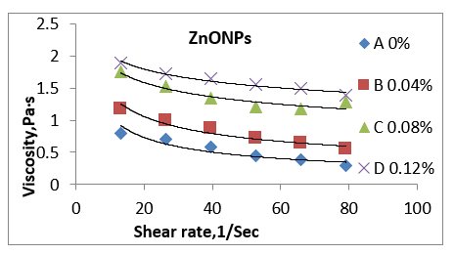 | 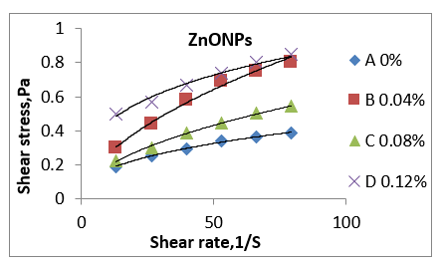
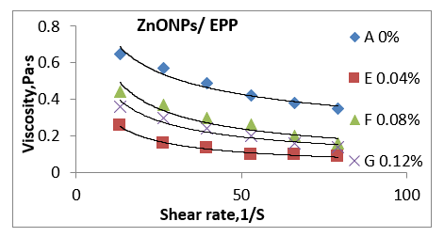 | 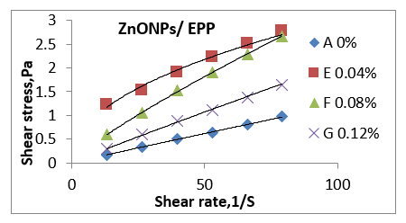
Figure 1. Shear rate, shear stress, and viscosity of nanofilm to produce an edible film-forming suspension solution of different treatments
Table 2 shows the relationship between the flow behaviour index (n) and the consistency index (k) at various treatments. Preparation of a prepared chitosan nanofilm solution combined with ZnONPs and ZnONPs/PPE to produce an edible film-forming suspension solution: A 0%, B 0.04%, C 0.08%, D 0.12%, E 0.04%, F 0.08%, and G 0.12%.
Treatments | Viscosity, cp |  |  | Shear Stress, Pa
 | k | n | R² | k | n | R²
A 0% | 3.697 | 0.541 | 0.879 | 0.0674 | 0.4021 | 0.997
Preparation of nanofilm solution combined with ZnONPs to produce an edible film-forming suspension solution
B 0.02% | 3.645 | 0.414 | 0.943 | 0.0705 | 0.5648 | 0.9935
C 0.04% | 3.046 | 0.218 | 0.007 | 0.0586 | 0.5102 | 0.9972
D 0.06% | 2.9136 | 0.162 | 0.0963 | 0.2199 | 0.3058 | 0.9816
Preparation of nanofilm solution combined with ZnONPs/PPE to produce an edible film-forming suspension solution
E 0.02% | 1.239 | 0.616 | 0.9881 | 0.3516 | 0.4662 | 0.9852
F 0.04% | 23.001 | 0.542 | 0.9052 | 0.0678 | 0.8404 | 0.9997
G 0.06% | 1.5675 | 0.533 | 0.9435 | 0.0253 | 0.9579 | 0.9985
L.S.D | 0.389 | 0.148 | 0.353 | 1.90 | 0.152 | n.s
Standard error | 0.1285 | 4.8870 | 0.1164 | 6.281 | 5.0185 | 0.04312
Mean | - | - | - | - | - | -
A | 3.695 | 0.5503 | 0.885 | 0.0994 | 0.43803 | 0.8943
B | 3.645 | 0.4340 | 0.939 | 0.9716 | 0.59893 | 0.9415
C | 3.123 | 0.2206 | 0.140 | 0.1933 | 0.5780 | 0.9604
D | 2.91 | 0.2330 | 0. 390 | 0.2296 | 0.3319 | 0.9452
E | 1.260 | 0.6483 | 0.9620 | 0.3402 | 0.5104 | 0.9204
F | 23.310 | 0.546 | 0.8960 | 0.0681 | 0.8651 | 0.9582
G | 1.59 | 0.5483 | 0.9328 | 0.0909 | 0.9439 | 0.5878
(A) = PPE extracts, 5% (0.1%) wt% chitosan (B) = ZnONPs, 1% (0.02%) wt% chitosan (C) = ZnONPs, 2% (0.04%) chitosan (D) weight percent = ZnONPs, 3% (0.06%) wt% chitosan weight (E) = ZnONPs 1%/PPE1% (0.02%) 2% ZnONPs/2% PPE (0.04%) Chitosan weight (F) Chitosan weight (G) = ZnONPs 3%/PPE3% (0.06%) chitosan weight (n.s. = not statistically significant).

The physical and mechanical properties of the prepared nano-edible coating and film solution are combined with ZnONPs and ZnONPs/EPP to produce edible coatings and films.
As shown in Table 3, the treatment, nanoscale films prepared in both ZnONPs and ZnONPs/EPP edible film and coating indicated that the thickness values at different treatments were A 0%, B 0.02%, C 0.04%, D 0.06%, E 0.02%, F 0.04%, and G 0.06%, which gradually increased in thickness with increasing concentration. It was also noted that the nano (ZnONPs) edible film B 0.02% 132, C 0.04%137 and D 0.06%140 um was less in thickness than the concentration of samples following E 0.02%145, F 0.04%160 and G 0.06%175 um nano (ZnONPs/EPP) edible film, as compared to the control A 0% thickness value of 186 um, where it was higher than the treatments. It was also observed that the tensile strength in the treatments B, C, and D, 66.22 N, 34.23 N, and 48.34 N, respectively, was higher than that of the E, F, and G, 54.35 N, 26.24 N, and 46.12 N, respectively, while the elongation was found to be less in the B, C, and D, 24.69 N, 23.65 N, and 22.68% N, respectively, than that of the E, F, and G, 26.23, 28.35, and 33.18%, as compared with the first initial control samples, compared with the A 0% tensile strength (70.23 N) and elongation (40.45%). When compared to the first initial control samples, the permeability of gases O₂ and CO₂ in treatments B, C, and D, 26.84, 39.34, and 43.55, and 40.85, 47.66, and 50.52, respectively, was lower than that of treatments E, F, and G, 40.23, 45.14, and 51.42, and 52.51. The permeability of gases was higher (O₂, 56.26 M³/M²10^{–7} daymmHg, and CO₂, 65.45 M³/M²10^{–8} daymmHg). It was also observed that the permeability of water vapor, the water vapour transmission rate, and the solubility in water were higher in the B, C, and D treatments than in the other treatments, E, F, and G. As compared with the first initial control samples, it had higher permeability. It was much higher than adding the film ZnONPs, and when GSE was added to ZnONP, the tensile strength was periodically increased, according to [18]. The high elongation of the film is always a desirable characteristic for use in food applications [35]. All the main factors significantly affected the mechanics of the film, as described below. The chitosan film had an 18% higher elongation than the chitosan film, and in addition to the incorporation of thymol, this reduced the chitosan layer [36, 37]. In general, the as-prepared flake thickness was observed for chitosan-containing films with ZnONPs as plasticizer (B, 132 um), followed by C, (137 um), and (140 um). (145, 160, and 175 microns). medium thickness (between 145, 160, and 175 um), as observed in increased ZnONPs and PPE compared to (A, 186 m) structure thickness, increased zeta potential [38].
Table 3. Physical and mechanical properties, permeability, and thickness of the prepared nano-edible coating and film solution in combination with ZnONPs and ZnONPs/EPP to produce edible coatings and films
Treatments | Thickness  Um | Tensile strength  N | Elongation  % | O₂  M³M/M²×10⁻⁷day·mmHg | CO₂  M³·M/M²×10⁻⁸day·mmHg | Water Vapors  Transmission Rate, g/hr·m² | Water Vapors  g·mm/m²·day·mmHg | Solubility in Water  %
A 0% | 186 | 70.23 | 40.45 | 56.26 | 65.45 | 45 | 0.1707 | 80.34
produced edible film of prepared nano edible coating & films combined with ZnONPs to produce edible coating and films
B 0.02% | 132 | 66.22 | 24.69 | 36.84 | 40.85 | 19.94 | 0.1342 | 65.27
C 0.04% | 137 | 34.23 | 23.65 | 39.34 | 47.66 | 27.63 | 0.1430 | 67.34
D 0.06% | 140 | 48.34 | 22.68 | 43.55 | 50.52 | 33.44 | 0.1538 | 70.78
produced edible film of prepared nano edible coating & films combined with ZnONPs and ZnONPs/PPE to produce edible coating and films
E 0.02% | 145 | 54.35 | 26.23 | 40.23 | 52.51 | 16.62 | 0.1315 | 29.18
F 0.04% | 160 | 26.24 | 28.35 | 45.14 | 56.77 | 19.35 | 0.1240 | 25.47
G 0.06% | 175 | 46.12 | 33.18 | 51.42 | 58.64 | 24.28 | 0.1138 | 22.28
L.S.D | 1.75 | 1.73 | 1.76 | 1.70 | 1.77 | 1.72 | n.s | 8.927
Standard error | 0.5773 | 0.5710 | 0.5803 | 0.5637 | 0.5864 | 0.568 | 4.178 | 2.9433
Mean | - | - | - | - | - | - | - | -
A | 186 | 70.56 | 40.51 | 83.5 | 65.62 | 45 | 0.1640 | 80.70
B | 132 | 66.61 | 24.59 | 72.5 | 40.71 | 19.78 | 0.1519 | 65.63
C | 137 | 34.62 | 23.57 | 65.76 | 47.65 | 27.51 | 0.1585 | 67.59
D | 140 | 48.62 | 22.66 | 54.70 | 50.57 | 33.50 | 0.1620 | 70.84
E | 145 | 54.55 | 26.47 | 52.56 | 52.49 | 16.60 | 0.1540 | 29.60
F | 160 | 26.99 | 28.58 | 61.56 | 56.69 | 19.51 | 0.1520 | 25.66
G | 175 | 46.59 | 33.38 | 64.53 | 58.51 | 24.45 | 0.1449 | 15.33
(A) = PPE extracts, 5% (0.1%) wt% chitosan (B) = ZnONPs, 1% (0.02%) wt% chitosan (C) = ZnONPs, 2% (0.04%) chitosan (D) weight percent = ZnONPs, 3% (0.06%) wt% chitosan weight (E) = ZnONPs 1%/PPE1% (0.02%) 2% ZnONPs/2% PPE (0.04%) Chitosan weight (F) Chitosan weight (G) = ZnONPs 3%/PPE3% (0.06%) Chitosan weight n.s. stands for "not significantly."
Determination of particle size distribution and Zeta potential-produced edible film of the prepared nano-edible coating and film solution combined with ZnONPs and ZnONPs/PPE to produce edible coating and film The solution formed:
Particle size
The results obtained are shown in Table 2 and Figure 2. Treatments (E20%, F40%, and G60%) were higher than the treatments A 0%, B 0.02%, C 0.04%, D 0.06%, E 0.02%, F 0.04%, and G 0.06%) in both polydisparity index (PdI) and hydrodynamic diameter of particle size (nm). It was found that the peaks were (0.648, 0.503, 0.771, and 134, 824.6, and 966 nm) for B 0.04%, C 0.08%, and D 0.12%, respectively. While the peak was E 0.04%, F 0.08%, and G 0.12%, the peak was 0.639, 00.650, and 0.503 and 110.6, 188.7, and 873.6 nm) respectively, as compared with initial control samples. a 0% practical size distribution (nm) in both the polydispersity index (PdI) of 0.450 and the hydrodynamic diameter of particulate size (nm) of 1319. A decrease of about 200 nm in the particle size around the charges in the aqueous solution was also observed after the treatment. Where the nanosize appeared at around 450 nm, which led to a decrease in the particle size, the zeta potential value decreased. Suspended particles with zeta potentials of above +30 or less than 30 mV repel each other because they are considered stable, but if the zeta potential is between +30 and 30 mV, they tend to attract each other [39, 40].
Zeta potential
The results show in Table 4 and Figure 3 that the Zeta potential distribution and Zeta Deviation (mV) were recorded for the treatment at a peak of (52.4, 36.5, and 29.5) and (4.17, 3.61, and 3.20) for B 0.02%, C 0.04% and D 0.06%, respectively. While it was discovered that the concentration of the treatments' Zeta potential distribution and Zeta Deviation (mV), E 0.02%, F 0.04%, and G 0.06% were recorded for the treatment in the peak as (39.2, 42.5, and 40.9) and (3.89, 3.81, and 3.61), respectively, when compared to the initial control samples, A 0% in both Zeta potential distribution (49.3) and Zeta Deviation (mV) was recorded at 5.12 (mV). The zeta potential is an important indicator of surface charges because it measures the electric charge at the colloidal particle boundary. The zeta potential determines the electrostatic repulsion between them and is responsible for their stability against sedimentation. It is usually obtained by measurement and conversion from the electrical kinetics of particles, tests, and materials (ASTM 2003). A zeta potential with an absolute value greater than 30 mV indicates "medium to good" colloidal system (ASTM) stability. The higher the zeta potential, the better the dispersion stability. Desirable zeta potentials can be obtained by [41,42]. The reason for the increase in zeta potential may be due to the fact that the components of the chitosan complex polymer with glacial acetic acid and PPE extracts, 5%, were the reason for the increase. Also, the reason for the increase in zeta potion may be due to the immiscibility of the solution, and this appeared in the electron microscope with a crack in the control film. As seen in the increased ZnO NPs/PPE in comparison to (A, 186 m), the thickness of the structure increased the zeta potential [31].
Table 4. Measured particle size and zeta potential of nanotechnology in prepared nano-edible coating and film solutions combined with ZnONPs and ZnONPs/PPE to produce edible coatings and film solutions formed from them
Treatments | Partical Size Distribution (nm) |  | Zeta Potential (mv)
 | Poly  disparity Index’s Pdi | Hydrodynamic  Diameter nm | Z-Potential | Z-Deviation
A 0% | 0.450 | 1312 | −49.3 | 5.12
produced edible film of prepared nano edible coating & films solution combined with ZnONPs to produce edible coating and films
B 0.02% | 0.648 | 134 | 52.4 | 4.17
C 0.04% | 0.503 | 824.6 | 36.61 | 3.61
D 0.06% | 0.771 | 966 | 29.5 | 3.20
produced edible film of prepared nano edible coating & films solution combined with ZnONPs and ZnONPs/PPE to produce edible coating and films
E 0.02% | 0.639 | 110.6 | 39.2 | 3.89
F 0.04% | 0.650 | 188.7 | 42.5 | 3.81
G 0.06% | 0.503 | 873.6 | 40.9 | 3.61
L.S.D | 8.01 | 31.08 | 18.61 | 0.455
Standard error | 0.02641 | 10.2470 | 6.138 | 0.150
Mean | - | - | - | -
A | 0.45 | 1309 | 32.866 | 5.19
B | 0.65 | 134 | 52.46 | 4.31
C | 0.50 | 824 | 36.60 | 3.51
D | 0.81 | 966 | 29.56 | 3.26
E | 0.63 | 136.86 | 38.35 | 3.37
F | 0.65 | 186 | 42.60 | 3.80
G | 0.53 | 8.75.2 | 40.77 | 3.49
(A) = PPE extracts, 5% (0.1%) wt% chitosan (B) = ZnONPs, 1% (0.02%) wt% chitosan (C) = ZnONPs, 2% (0.04%) chitosan (D) weight percent = ZnONPs, 3% (0.06%) wt% chitosan weight (E) = ZnONPs 1%/PPE1% (0.02%) 2% ZnONPs/2% PPE (0.04%) Chitosan weight (F) Chitosan weight (G) = ZnONPs 3%/PPE3% (0.06%) Chitosan weight n.s. stands for "not significantly."
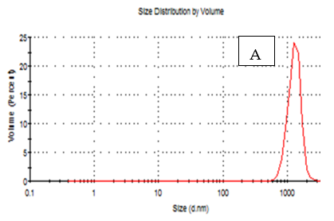 | 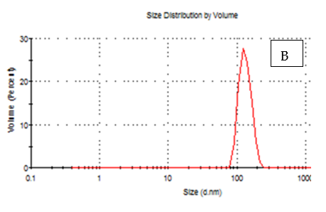
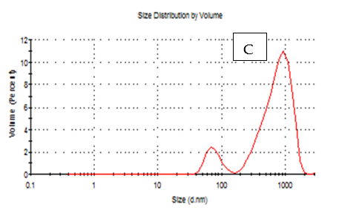 | 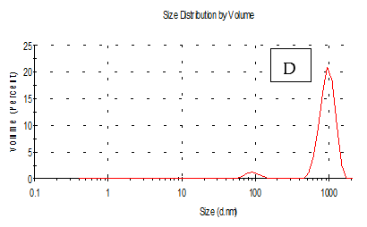
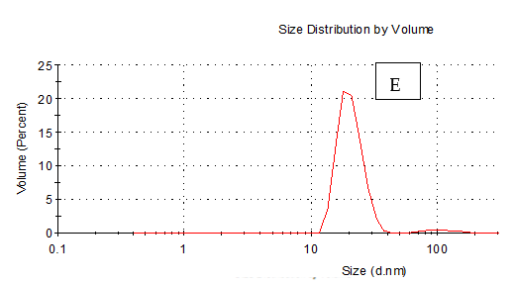 | 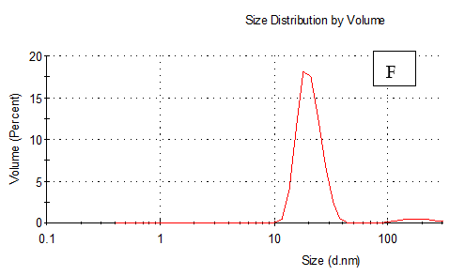
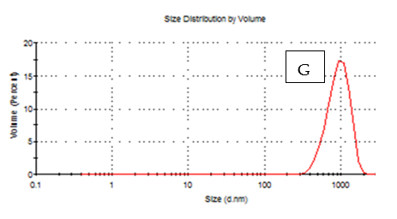

Figure 2: Specific sizes of nano-edible coatings and films combined with ZnONPs and ZnONPs/EPP to produce an edible film-forming suspension solution of various treatments (A) = PPE extracts, 5% (0.1%) wt% chitosan (B) = ZnONPs, 1% (0.02%) wt% chitosan (C) = ZnONPs, 2% (0.04%) Chitosan (D) weight percent = ZnONPs, 3% (0.06%). wt% chitosan weight (E) = ZnONPs 1%/PPE1% (0.02%) 2% ZnONPs/2% PPE (0.04%) chitosan weight (F) chitosan weight (G) = ZnONPs 3%/PPE3% (0.06%) Chitosan weight n.s. stands for "not significantly."
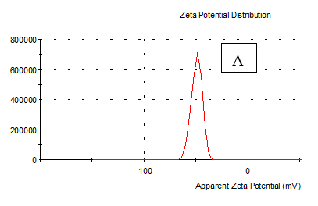 | 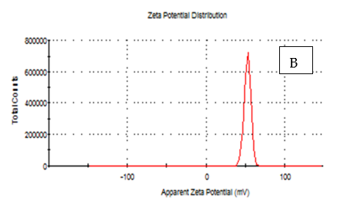
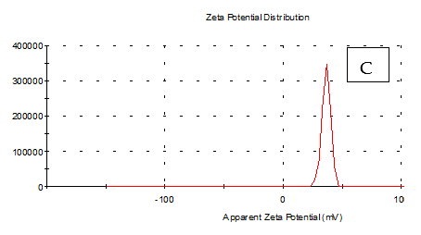 | 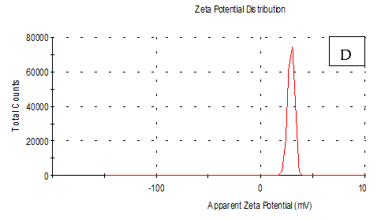
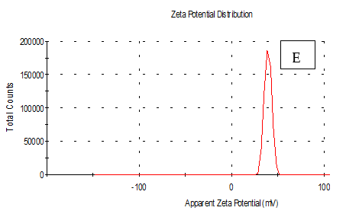 | 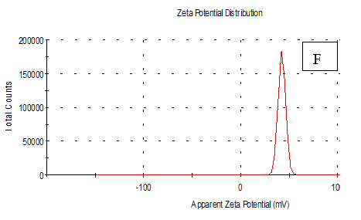
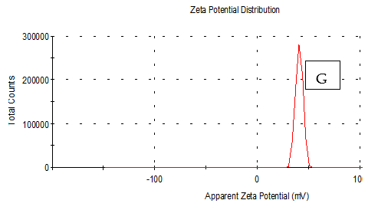
Figure 3. Zeta potentials of prepared nanoedible coatings and films were combined with ZnONPs and ZnONPs/EPP to produce an edible film-forming suspension solution of different treatments. (A) = PPE extracts, 5% (0.1%) wt% chitosan (B) = ZnONPs, 1% (0.02%) wt% chitosan (C) = ZnONPs, 2% (0.04%) chitosan (D) wt% = ZnONPs, 3% (0.06%) wt% chitosan weight (E) = ZnONPs 1%/PPE1% (0.02%) ZnONPs 2%/PPE2% (0.04%) chitosan weight (F) chitosan weight (G) = ZnONPs 3%/PPE3% (0.06%) Chitosan weight n.s. stands for "not significantly."

Scanning electron microscopy (SEM) microstructure of prepared nanoedible coatings and films combined with ZnONPs and ZnONPs/EPP to produce edible films:
There are seven microscopic images of nanoedible coatings and films combined with ZnONPs and ZnONPs/EPP to produce edible film. After taking the cross-section, the morphology of the surface was investigated using SEM images (Figure 4), and the surface roughness was estimated using nanoedible coatings and films. The SEM images showed that the edible films were intact and smooth without any noticeable delamination on the surface, which was found to rise with increasing concentration upon different treatments. In the figure of prepared nano-edible coatings and films combined with ZnONPs and ZnONPs/EPP to produce edible films, A = 0%, B = 0.02%, C = 0.04%, D = 0.06%, E = 0.02%, F = 0.04%, and G = 0.06% are shown. It was found that the control, a 0% treatment, has cracks in the edible film due to poor treatment that does not contain ZnONPs and ZnONPs/EPP. The treatments in the figure also demonstrated that the addition of ZnONPs and ZnONPs/EPP properties results in edible films with a smooth surface flush D with some rough ridges, and treatment G discovered roughness of transparent appearance and droplets of elliptical shape. Treatment B was homogeneous with bubble drops compared to a spherical morphological droplet. In general, the edible film is composed of a homogeneous solution with some compact fine grains and an intact smooth crystal morphology in a continuous matrix. It can be concluded that these studies are useful for learning about the microstructure and membrane morphology, which can help in selecting the edible nanofilm formulas for coating and packing. Our results are in agreement with those obtained by [36]. SEM images found that the elegant CMC film was smooth and intact without any deformation, and the surface was clear. The surface roughness was slightly increased in the films supplemented with grape seed extract, which was confirmed by the higher surface roughness of the CMC/grape seed extract film compared to the elegant CMC film [15,43]. The presence of a gelatinous mass with cracking in the control film was observed, which may be due to the incompatibility of the complex polymer with pomegranate peel extract. Generally, the scanning microscopy study may be useful for recognizing the microstructure and morphology of the produced films, which can be helpful in choosing the proper film formula for coating and packaging. Purposes. Also, the colour appearance of produced films may be important because it could affect consumer acceptance of coated items [44].
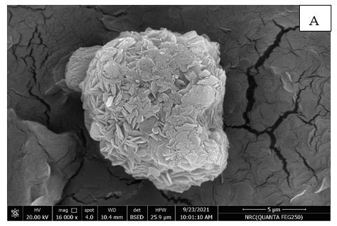
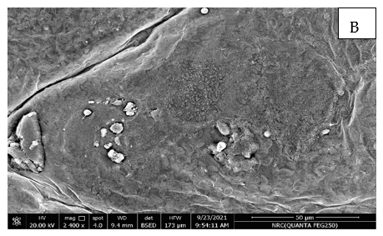 | 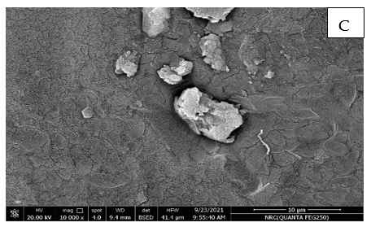
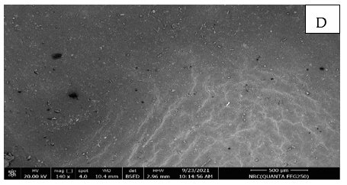 | 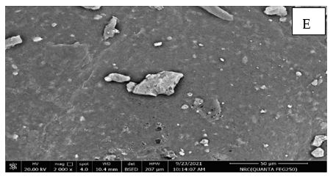
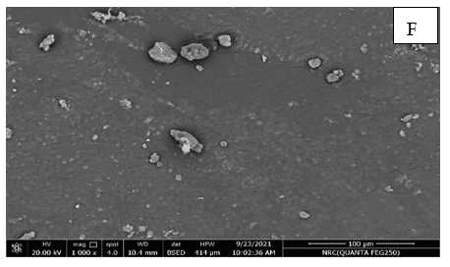 | 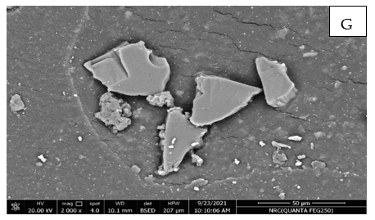
Figure 4. Microstructure of prepared nano edible coatings and films combined with ZnONPs and ZnONPs/EPP to produce edible films using scanning electron microscopy (SEM) technology using scanning electron microscopy (SEM) at different treatments. (A) = PPE extracts, 5% (0.1%) wt% chitosan (B) = ZnONPs, 1% (0.02%) wt% chitosan (C) = ZnONPs, 2% (0.04%) chitosan (D) wt% = ZnONPs, 3% (0.06%) wt% chitosan weight (E) = ZnONPs 1%/PPE1% (0.02%) ZnONPs 2%/PPE2% (0.04%) chitosan weight (F) chitosan weight (G) = ZnONPs 3%/PPE3% (0.06%) Chitosan weight n.s. stands for "not significantly".
Determination of the apparent and transmittance colours of the edible films of prepared nano-edible coatings and films combined with ZnONPs and ZnONPs/PPE to produce edible films using scanning electron microscopy (SEM) technology:
The results obtained are presented in Table 5 and Figures 5 and 6. According to the curves in Figure 1, the apparent colour increased with increasing concentration at different treatments: A = 0%, B = 0.02%, C = 0.04%, D = 0.06%, E = 0.02%, F = 0.04%, and G = 0.06% of prepared nanoedible coatings and films combined with ZnONPs and ZnONPs/PPE to produce edible films. The treatments also had a higher apparent colour value as recorded (B 0.04%, 64.51, 0.42, 6.49, and 31.01; C 0.08%, 62.45, 0.60, 6.36, and 27.65; and D 0.012%, 61.48, 0.75, 7.05, and 24.205 for L, a, b, and E, respectively), while the treatment (E 0.04%, 62.44, 0.51, 7.50, 26.70;A 0% for L, a, b, and E was 56.50, 0.22, 7.04, and 56.56. On the other hand, the barrier and transparency of the films were evaluated by measuring the percent light transmittance at T550, 430, and 395 nm, respectively. It was found that the treatments decreased with increasing concentration at different treatments in both B 0.04%, C 0.08%, and D 0.12% and E 0.04%, F 0.08%, and G 0.12% compared to the control A 0% sample, and the results were as follows: B20%, 73.1, 62.2, 53.7, and C40%, 65.9, 52.3, 43.2, and D60%, 54.7, 44.2, and 37.3 for T550, 430, and 395 nm respectively, while the treatment, E20%, 53.4, 39.4, 28.4, and F40%, 61.6, 45.4, and G60%, 64.6, 54.4, and 63.4 for T550, 430, and 395 nm respectively. Interestingly, the addition of nanomaterial did not significantly reduce the transparency of the film (by less than 10%), but significantly reduced the light transmittance depending on the concentration of nanomaterial. When two wt% of nanomaterial were added, the T280 of the film was reduced by more than 50%. These results indicate that the addition of nanomaterials significantly increased the UV barrier property without sacrificing the transparency of the film. The UV blocking property of pectin/agar films containing nanomaterials is mainly attributed to the UV light absorption function of the nanomaterial. [22,24,35,45].

Table 5 shows the colour apparent and light transmittance of nanoedible coatings and films combined with ZnONPs and ZnONPs/EPP to produce edible films using scanning electron microscopy (SEM) technology.
Films | L | a | b | $∆$E | T550 nm | T430 nm | T395 nm
A 0% | 56.5 | 0.22 | 7.04 | 56.94 | 83.2 | 57.1 | 47.3
produced edible film of prepared nano edible coating & films solution combined with ZnONPs to produce edible coating and films
B 0.02% | 64.51 | 0.42 | 6.49 | 31.01 | 73.1 | 62.2 | 53.7
C 0.04% | 62.45 | 0.60 | 6.36 | 27.65 | 65.9 | 52.3 | 43.2
D 0.06% | 61.48 | 0.75 | 7.05 | 24.25 | 54.7 | 44.2 | 37.3
produced edible film of prepared nano edible coating & films solution combined with ZnONPs and ZnONPs/PPE to produce edible coating and films
E 0.02% | 62.44 | 0.51 | 7.50 | 26.70 | 53.4 | 39.4 | 28.4
F 0.04% | 63.40 | 0.76 | 10.72 | 30.58 | 61.6 | 45.4 | 31.5
G 0.06% | 61.20 | 0.64 | 12.74 | 26.62 | 64.3 | 54.3 | 63.4
L.S.D | 1.643 | 0.0015 | 0.487 | 1.748 | 1.709 | 1.787 | 1.509
Standard error | 0.5418 | 0.024 | 0.1606 | 0.5766 | 1.709 | 0.5893 | 0.4976
Mean | - | - | - | - | - | - | -
A | 55.41 | 0.23 | 7.06 | 55.86 | 83.5 | 58 | 47.6
B | 64.67 | 0.40 | 6.573 | 30.66 | 72.5 | 62.53 | 53.73
C | 62.55 | 0.62 | 6.233 | 27.69 | 65.76 | 51.53 | 42.56
D | 61.41 | 0.74 | 6.983 | 24.55 | 54.70 | 44.6 | 37.56
E | 62.58 | 0.50 | 7.343 | 25.66 | 52.65 | 93.66 | 28.46
F | 63.46 | 0.73 | 10.496 | 30.73 | 61.65 | 45.66 | 31.33
G | 61.36 | 0.61 | 12.13 | 25.67 | 64.53 | 54.60 | 63.56
(A) = PPE extracts, 5% (0.1%) wt% chitosan (B) = ZnONPs, 1% (0.02%) wt% chitosan (C) = ZnONPs, 2% (0.04%) chitosan (D) weight percent = ZnONPs, 3% (0.06%) wt% chitosan weight (E) = ZnONPs 1%/PPE1% (0.02%) %ZnONPs/2% PPE (0.04%) Chitosan weight (F) Chitosan weight (G) = ZnONPs 3%/PPE3% (0.06%) Chitosan weight n.s. stands for "not significantly.".
Figure 5: The apparent colour (light transmittance) of edible films prepared with nanoedible coating and films solution combined with ZnONPs and ZnONPs/PPE on edible films at various treatments was
measured. A = 0%, B = 0.04%, C = 0.08%, D = 0.12%, E = 0.04%, F = 0.08%, and G = 0.12%.
Figure 6: The apparent colour (Minolta Chroma) of edible films prepared with nanoedible coating and films solution combined with ZnONPs and ZnONPs/PPE on edible films at different treatments was measured. A = 0%, B = 0.04%, C = 0.08%, D = 0.12%, E = 0.04%, F = 0.08%, and G = 0.12%.
Manfalouty pomegranate fruit applications of selected appropriate edible film nanomaterials:
physicochemical and microbiological characteristics of coated manfalouty pomegranate fruit during storage
3.1. Weight Loss Percentage
The results obtained are presented in Table 6. From this table, it could be observed that the weight loss increased with increasing the storage period at a cold temperature for treatments A = 0%, B = 0.02%, C = 0.04%, D 0.06%, E = 0.02%, F = 0.04%, and G = 0.06% packaged in nano-coated tablets. Compared to the control, A0% indicated a higher weight loss than the nano-coated treatments. It was also noted that the greater the percentage of treatment concentration, the greater the weight loss in nanocoated treatments. It was also pointed out that the treatments ZnONPs / PPE were better than ZnONPs in reducing the weight loss percentage compared to the control sample, which was much higher. The results of the study showed that the best treatment was G, followed by D, followed by F, C, E, and B, as compared with control A0%, which was the least. Typically, weight loss occurs during fruit storage due to its respiratory process, the transference of humidity, and some oxidation processes [46]. This weight loss is correlated with an increase in water loss due to a rise in transpiration and respiration [47]. The high surface-to-volume ratio explains the sweetness of cherries and their low skin diffusion resistance [48]. Similar results were reported in previous studies with other edible coatings, which concluded that edible films created a physical barrier against moisture loss and reduced the transpiration rate [49, 50].
Table 6. Effect of edible film and coatings on weight loss (%) of manfalouty pomegranate during storage at 2 °C
Treatments | A  5% (0.1%) | ZnONPs |  |  | ZnONPs/PPE
 |  | B  1% (0.02%) | C  2% (0.04%) | D  3% (0.06%) | E  1% (0.02%) | F  2% (0.04%) | G  3% (0.06%)
Zero time | - | - | - | - | - | - | -
5 | 2.25 | 2.20 | 1.90 | 1.71 | 2.10 | 1.93 | 1.82
10 | 3.89 | 2.50 | 1.98 | 1.87 | 2.45 | 2.04 | 1.89
15 | - | 2.85 | 2.25 | 1.92 | 2.76 | 2.15 | 1.90
20 | - | 2.90 | 2.50 | 1.99 | 2.88 | 2.45 | 1.95
L.S.D S = 1. 15 T = 1. 54 S&T = 0.18]

spoiled reject samples (-) T = LSD Treatments LSD Storage Time = S LSD = T * S (Storage Period * Treatments). means that within a column showing the same letters, they are not significantly different (p ≥ 0.05). (A) = PPE extracts, 5% (0.1%) wt% chitosan (B) = ZnONPs, 1% (0.02%) wt% chitosan (C) = ZnONPs, 2% (0.04%) wt% chitosan (D) = ZnONPs, 3% (0.06%) wt% chitosan (E) = 1% ZnONPs/1% PPE (0.02%) wt% of chitosan (F) = ZnONPs 2%/PPE2% (0.04%) wt% of chitosan (G) = ZnONPs 3%/PPE3% (0.06%). wt% of chitosan
3.2. Total Soluble Solids (TSS%)
Table 7 shows the changes in the TSS% of edible coatings on pomegranate. The TSS% of nano-coated pomegranate gradually decreased with increasing the storage period at cold temperatures in both treatments ZnONPs/PPE and ZnONPs.It was also discovered that the percentage of TSS decreased more in the treatments ZnONPs and PPE than in the control A% sample, where the rate of total solids loss was much higher than in the coated treatments.This reduction might be due to the respiratory process. All treatments significantly reduced the loss of TSS%, except coating treatment G, which recorded the highest values (12.74%). Coating a film on the surface of fruits reduces their respiration rate and vital processes, which reduces the loss of TSS% during storage. The total soluble solids of uncoated and coated fruits after 20 days of storage This value increased slightly during storage, probably due to the water loss, activity of hydrolytic enzymes, or decrease in respiration rate and conversion of sugars into CO2 and H2O during the storage period [49, 50].
Table 7. Effect of edible film and coatings on total soluble solids (TSS) of manfalouty pomegranate during storage at 2 °C
Treatments | A (PPE),  5% (0.1%) | ZnONPs |  |  | ZnONPs/PPE
 |  | B  1% (0.02%) | C  2% (0.04%) | D  3% (0.06%) | E  1% (0.02%) | F  2% (0.04%) | G  3% (0.06%)
Zero time | 15.75 | 15.75 | 15.75 | 15.75 | 15.75 | 15.75 | 15.75
5 | 14.56 | 15.69 | 15.62 | 15.58 | 15.73 | 15.60 | 15.53
10 | 12.10 | 14.85 | 14.44 | 14.38 | 14.81 | 14.41 | 14.34
15 | - | 13.68 | 13.35 | 13.28 | 13.63 | 13.32 | 13.25
20 | - | 12.15 | 12.20 | 12.49 | 12.22 | 12.57 | 12.76
L.S.D S = 1. 11 T = 1. 45 S&T = 0.21

spoiled reject samples (-) T = LSD Treatments LSD Storage Time = S LSD = T * S (Storage Period * Treatments). means that within a column showing the same letters, they are not significantly different (p ≥ 0.05). (A) = PPE extracts, 5% (0.1%) wt% chitosan (B) = ZnONPs, 1% (0.02%) wt% chitosan (C) = ZnONPs, 2% (0.04%) wt% chitosan (D) = ZnONPs, 3% (0.06%) wt% chitosan (E) = 1% ZnONPs/1% PPE (0.02%) wt% of chitosan (F) = ZnONPs 2%/PPE2% (0.04%) wt% of chitosan (G) = ZnONPs 3%/PPE3% (0.06%). wt% of chitosan
3.3. Total Acidity
The changes in total acidity of pomegranate were determined during the storage period, i.e., The obtained results are recorded in Table 8. The results indicated that the total acidity gradually decreased with increasing amounts of nanocoated pomegranate during the storage period. Total acidity was significantly reduced as a function of storage time for all studied treatments. It shows the delay in using organic acid in enzymatic respiration. All treatments showed significant differences at the end of storage; treated auricles by ZnONPs carried by chitosan or chitosan ZnONPs/PPE recorded the highest values of acidity compared with other treatments and the control. It is also considered that coatings reduce the respiration rate and may delay the utilization of organic acids. Retention of acidity has been reported previously for various strawberries treated with edible coatings and films. [21]. The acidity of uncoated and coated fruits after 20 days of storage Acidity estimates the fruit’s organic acid content, which generally decreases during postharvest storage due to the use of organic acids as substrates for respiratory metabolism [52]. Acidity decreased during storage time in uncoated and coated fruit samples, but this decrease was less noticeable in coated fruit [50].
Table 8. Effect of edible film and coatings on the acidity of manfalouty pomegranate during storage at 2 °C
Treatments | A(PPE),  5% (0.1%) | ZnONPs |  |  | ZnONPs/PPE
 |  | B  1% (0.02%) | C  2% (0.04%) | D  3% (0.06%) | E  1% (0.02%) | F  2% (0.04%) | G  3% (0.06%)
Zero time | 0.81 | 0.81 | 0.81 | 0.81 | 0.81 | 0.81 | 0.81
5 | 0.80 | 0.83 | 0.82 | 0.84 | 0.82 | 0.81 | 0.84
10 | 0.78 | 0.82 | 0.81 | 0.80 | 0.81 | 0.80 | 0.79
15 | - | 0.80 | 0.79 | 0.79 | 0.79 | 0.78 | 0.77
20 | - | 0.79 | 0.78 | 0.75 | 0.78 | 0.76 | 0.74
L.S.D S = 1. 15 T = 1. 39 S&T = 0.14

spoiled reject samples (-) T = LSD Treatments LSD Storage Time = S LSD = T * S (Storage Period * Treatments). means that within a column showing the same letters, they are not significantly different (p ≥ 0.05). (A) = PPE extracts, 5% (0.1%) wt% chitosan (B) = ZnONPs, 1% (0.02%) wt% chitosan (C) = ZnONPs, 2% (0.04%) wt% chitosan (D) = ZnONPs, 3% (0.06%) wt% chitosan (E) = 1% ZnONPs/1% PPE (0.02%) wt% of chitosan (F) = ZnONPs 2%/PPE2% (0.04%) wt% of chitosan (G) = ZnONPs 3%/PPE3% (0.06%). wt% of chitosan
3.4. Ascorbic Acids
The obtained results are recorded in Table 9; the results indicate that the ascorbic acid decreased with increasing amounts of nanocoated pomegranate during storage. It was also found that the percentage of ascorbic acid decreased in treatments ZnONPs/PPE than in treatments ZnONPs compared to the control A% sample, where the rate of ascorbic acid loss was much higher than in the coated treatments. The decrease in ascorbic acid during storage may be due to the conversion of ascorbic acid to dehydroascorbic acid due to the action of ascorbic acid oxidase. Ascorbic acid is a potent free radical scavenger that prevents fruit degradation during ripening. The ascorbic acid content showed no significant difference (p > 0.05) between different samples during the storage time. In contrast, it was previously found that applying chitosan coatings enriched with pomegranate peel extract to guava decreased the loss of ascorbic acid during storage. Similar results of delays in ascorbic acid in chitosan-coated sweet cherries were reported [49]. who hypothesized that coating materials lowered the oxygen permeability and the activity of enzymes, resulting in the prevention of the oxidative deterioration of ascorbic acid [50].
Table 9. Effect of edible film and coatings on the ascorbic acid of manfalouty pomegranate during storage at 2 °C
Treatments | A(PPE),  5% (0.1%) | ZnONPs |  |  | ZnONPs/PPE
 |  | B  1% (0.02%) | C  2% (0.04%) | D  3% (0.06%) | E  1% (0.02%) | F  2% (0.04%) | G  3% (0.06%)
Zero time | 17.50 | 17.50 | 17.50 | 17.50 | 17.50 | 17.50 | 17.50
5 | 12.45 | 13.62 | 13.10 | 12.37 | 13.54 | 13.01 | 12.13
10 | 11.18 | 13.40 | 12.89 | 11.86 | 13.22 | 12.65 | 11.49
15 | - | 12.13 | 12.48 | 11.28 | 12.88 | 12.25 | 11.42
20 | - | 12.26 | 11.32 | 11.05 | 12.63 | 11.86 | 11.26
L.S.D S = 1. 15 T = 1. 56 S&T = 0.15

spoiled reject samples (-) T = LSD Treatments LSD Storage Time = S LSD = T * S (Storage Period * Treatments). means that within a column showing the same letters, they are not significantly different (p ≥ 0.05). (A) = PPE extracts, 5% (0.1%) wt% chitosan (B) = ZnONPs, 1% (0.02%) wt% chitosan (C) = ZnONPs, 2% (0.04%) wt% chitosan (D) = ZnONPs, 3% (0.06%) wt% chitosan (E) = 1% ZnONPs/1% PPE (0.02%) wt% of chitosan (F) = ZnONPs 2%/PPE2% (0.04%) wt% of chitosan (G) = ZnONPs 3%/PPE3% (0.06%). wt% of chitosan
3.5. Anthocyanin Percentage
Data in Table 10 shows the effect of ZnONPs and chitosan combined with ZnONPs/PPE on the percentage of anthocyanin in Manfalouty pomegranate arils stored for 5, 10, 15, and 20 days at 2 °C during storage days. The anthocyanin content of auricles decreased during storage periods. However, after ten days of storage, results indicated highly significant differences between all treatments. ZnONPs carried by chitosan recorded the highest value (14.73%), followed by ZnONPs/PPE (14.62%). But after 20 days of storage periods, the data showed no significant differences. [6] noted that the essential oils had the lowest anthocyanin value. Anthocyanins, one of the major flavonoids, are natural, water-soluble pigments connected with the ripening stage of the fruit and are mainly used as an indicator of cherry quality. Cherry colour is influenced by the concentration and distribution of cyanidin-3-O-glucoside and cya-indin-3-O-rutinoside in the skin.As can be seen in Figure 3, anthocyanins increased during the storage period as ripening progressed. After harvest, the total anthocyanin content was 23–65 mg/100 g. The amounts of anthocyanin in chitosan enriched with olive leaf extract and control samples differed significantly (p 0.05).An increase in anthocyanins after harvest has been previously reported for other fruits such as strawberries and pomegranates and may be related to the anthocyanin synthesis in the fruit during storage. [49].

Table 10. Effect of edible film and coatings on the anthocyanin content of manfalouty pomegranate during storage at 2 °C
Treatments | A (PPE),  5% (0.1%) | ZnONPs |  |  | ZnONPs/PPE
 |  | B  1% (0.02%) | C  2% (0.04%) | D  3% (0.06%) | E  1% (0.02%) | F  2% (0.04%) | G  3% (0.06%)
Zero time | 18.95 | 18.95 | 18.95 | 18.95 | 18.85 | 18.85 | 18.85
5 | 17.55 | 18.25 | 17.88 | 17.38 | 18.12 | 17.66 | 17.10
10 | 16.42 | 17.86 | 16.90 | 16.48 | 17.52 | 16.52 | 16.22
15 | - | 17.23 | 16.18 | 15.80 | 17.10 | 15.80 | 15.38
20 | - | 16.56 | 15.46 | 14.73 | 16.34 | 15.22 | 14.62
L.S.D S = 1. 17 T = 1. 49 S&T = 0.19

spoiled reject samples (-) T = LSD Treatments LSD Storage Time = S LSD = T * S (Storage Period * Treatments). means that within a column showing the same letters, they are not significantly different (p ≥ 0.05). (A) = PPE extracts, 5% (0.1%) wt% chitosan (B) = ZnONPs, 1% (0.02%) wt% chitosan (C) = ZnONPs, 2% (0.04%) wt% chitosan (D) = ZnONPs, 3% (0.06%) wt% chitosan (E) = 1% ZnONPs/1% PPE (0.02%) wt% of chitosan (F) = ZnONPs 2%/PPE2% (0.04%) wt% of chitosan (G) = ZnONPs 3%/PPE3% (0.06%). wt% of chitosan
3.6. Total Microbial Count
The data show that total counts gradually increased as the cold storage period of pomegranate in both ZnONPs and ZnONPs/PPE of edible film nano-materials was increased.The results in Table 11 showed that the microbial load increased with increased storage in all storage treatments. Control A% treatment indicates higher counts than the coated nanomaterials. The growth of microorganisms increased with a prolonged storage period, particularly in the untreated arils. All types had lower levels of microbial lead in comparison to controls. The data revealed highly significant differences among all treatments, whatever the storage period. Ten days of storage time were squandered. ZnONPs/PPE combined with chitosan recorded the lowest value of 3.12 × 10¹ CFU/g, followed by ZnONPs combined with chitosan at 3.36 × 10¹ CFU/g. After 20 days of storage Adding nanoparticle material as an antimicrobial agent to coating emulsion improved the fruit’s microbial quality. It decreased microbial counts [51]. It found that the coating treatment of fruit and vegetables allowed limited gas exchange and respiration, preventing the fermentation process and minimising the microbial count. Also, they added that high microbial counts appeared after three weeks in control samples stored at room temperature. In addition, it was remarked that samples treated with non-nano coating showed higher counts after storage than those treated with nano coating. This may be due to the wax’s relatively high thickness, which prevents respiration and leads to anaerobic conditions and fruit degradation. In addition, it could be reported that the edible coating and film nanoparticle material have a remarkable effect on the rate of microbial counts during storage at a cooled temperature [52].
Table 11. Effect of edible film and coatings on the total microbial count of manfalouty pomegranate during storage at 2 °C
Treatments | A (PPE),  5% (0.1%) | ZnONPs |  |  | ZnONPs/PPE
 |  | B  1% (0.02%) | C  2% (0.04%) | D  3% (0.06%) | E  1% (0.02%) | F  2% (0.04%) | G  3% (0.06%)
Zero time | 0.37 | 0.37 | 0.37 | 0.37 | 0.37 | 0.37 | 0.37
5 | 2.67 | 1.70 | 1.95 | 1.99 | 1.82 | 2.10 | 2.12
10 | 3.10 | 2.25 | 2.60 | 2.78 | 2.34 | 2.93 | 2.94
15 | - | 2.86 | 3.16 | 3.55 | 2.92 | 3.49 | 3.75
20 | - | 3.82 | 3.70 | 3.36 | 3.83 | 3.66 | 3.12
L.S.D S = 1. 14 T = 1. 47 S&T = 0.16

spoiled reject samples (-) T = LSD Treatments LSD Storage Time = S LSD = T * S (Storage Period * Treatments). means that within a column showing the same letters, they are not significantly different (p ≥ 0.05). (A) = PPE extracts, 5% (0.1%) wt% chitosan (B) = ZnONPs, 1% (0.02%) wt% chitosan (C) = ZnONPs, 2% (0.04%) wt% chitosan (D) = ZnONPs, 3% (0.06%) wt% chitosan (E) = 1% ZnONPs/1% PPE (0.02%) wt% of chitosan (F) = ZnONPs 2%/PPE2% (0.04%) wt% of chitosan (G) = ZnONPs 3%/PPE3% (0.06%). wt% of chitosan

3.7. Mold and Yeast
The results are shown in Table 12. Mold and yeast counts gradually increased as storage time at a cooled temperature increased.The data revealed highly significant differences among all treatments, whatever the storage period. Ten days of storage time were squandered. ZnONPs combined with chitosan recorded the lowest value of 2.75 × 10¹ CFU/g, followed by ZnONPs/PPE combined with chitosan at 2.46 × 10¹ CFU/g. after 20 days of storage. Edible coatings with 0.2% ZnO2 were the most effective, decreasing yeast and mould growth at 6 and 12 days, though the bacterial load increased after 12 days of storage. The combination of CMC with nano-ZnO2 helped maintain bioactive compounds in the ready-to-eat pomegranate [53]. who noted that the essential oils reduced yeast and mould colonies [14]. On orange fruit, it is stated that essential oils do not control the producing agent of the blue fungus. In addition, bio-films and coatings act as carriers of food additives (i.e., antioxidants and antimicrobials) and have been mainly considered in food preservation due to their ability to extend the shelf life.
Table 12. Effect of edible film and coatings on moulds and yeast of manfalouty pomegranate during storage at 2 °C
Treatments | A (PPE),  5% (0.1%) | ZnONPs |  |  | ZnONPs/PPE
 |  | B  1% (0.02%) | C  2% (0.04%) | D  3% (0.06%) | E  1% (0.02%) | F  2% (0.04%) |  | G  3% (0.06%)
Zero time | 0.16 | 0.16 | 0.16 | 0.16 | 0.16 |  | 0.16 | 0.16
5 | 1.65 | 1.15 | 1.35 | 1.57 | 1.18 |  | 1.45 | 1.75
10 | 1.86 | 1.43 | 1.62 | 1.86 | 1.52 |  | 1.79 | 1.98
15 | - | 1.66 | 1.84 | 2.15 | 1.73 |  | 1.98 | 2.46
20 | - | 1.89 | 2.38 | 2.75 | 1.46 |  | 2.17 | 2.46
L.S.D S = 1. 15 T = 1. 54 S&T = 0.12

spoiled reject samples (-) T = LSD Treatments LSD Storage Time = S LSD = T * S (Storage Period * Treatments). means that within a column showing the same letters, they are not significantly different (p ≥ 0.05). (A) = PPE extracts, 5% (0.1%) wt% chitosan (B) = ZnONPs, 1% (0.02%) wt% chitosan (C) = ZnONPs, 2% (0.04%) wt% chitosan (D) = ZnONPs, 3% (0.06%) wt% chitosan (E) = 1% ZnONPs/1% PPE (0.02%) wt% of chitosan (F) = ZnONPs 2%/PPE2% (0.04%) wt% of chitosan (G) = ZnONPs 3%/PPE3% (0.06%). wt% of chitosan
3.8. Color Changes
The colour changes were measured by recording lightness (L* value), chroma (intensity of color), and hue angle (ho). The lightness of the strawberries was affected by storage time (Table 13). The results indicated that the manfalouty pomegranate gradually decreased with an increasing storage period at cooling temperatures. The lightness (L*) gradually decreased during storage in both ZnONPs and ZnONPs/PPE manfalouty pomegranates. The highest decrease in lightness was observed in uncoated (control) manfalouty pomegranates. Changes in the hue-angle (h◦) value of coated fruit with storage time were slight and only became significant at the end of the storage period. Chroma was reduced by around 30% for control and 10% for coated fruit. The coating solution gave rise to significant differences in fruit colour by the end of the storage period and in the surface colour of fruits [54].
Table 13: Influence of edible film and coatings on colour (hue angle (h◦) of manfalouty pomegranate during storage at 2 °C)
Treatments | A (PPE),  5% (0.1%) | ZnONPs |  |  | ZnONPs/PPE
 |  | B  1% (0.02%) | C  2% (0.04%) | D  3% (0.06%) | E  1% (0.02%) | F  2% (0.04%) | G  3% (0.06%)
Zero time | 88.06 | 86.09 | 87.47 | 87.80 | 86.42 | 87.44 | 88.20
5 | 86.60 | 85.45 | 86.30 | 86.57 | 85.10 | 86.42 | 86.75
10 | 78.23 | 81.41 | 82.32 | 83.46 | 82.32 | 83.49 | 84.28
15 | - | 79.21 | 78.80 | 79.40 | 1579.42 | 80.48 | 80.86
20 | - | 74.49 | 75.19 | 76.40 | 75.76 | 76.45 | 77.46
L.S.D S = 1. 13 T = 1. 58 S&T = 0.17

spoiled reject samples (-) T = LSD Treatments LSD Storage Time = S LSD = T * S (Storage Period * Treatments). means that within a column showing the same letters, they are not significantly different (p ≥ 0.05). (A) = PPE extracts, 5% (0.1%) wt% chitosan (B) = ZnONPs, 1% (0.02%) wt% chitosan (C) = ZnONPs, 2% (0.04%) wt% chitosan (D) = ZnONPs, 3% (0.06%) wt% chitosan (E) = 1% ZnONPs/1% PPE (0.02%) wt% of chitosan (F) = ZnONPs 2%/PPE2% (0.04%) wt% of chitosan (G) = ZnONPs 3%/PPE3% (0.06%). wt% of chitosan
4.Conclusions

Physical and chemical properties were studied, e.g., rheological properties and parathyroid size distribution, zeta potential, and scanning electron microscopy films. Adding nanomaterials to edible coatings prolongs product shelf life, reduces the risk of pathogen growth, and improves the quality of fruit and vegetable surfaces by using low-cost substrates for nano-polymer production to produce edible coatings and film solutions. As this substance inhibits microbial growth and oxidation and improves the quality of the film, polysaccharides are extracted from polysaccharides to preserve the film from oxidation and microbial contamination, maintain the stability of the film, and extend the shelf life of food; acceptable sensory characteristics; appropriate barrier properties (CO2, O2, and water); microbial biochemical and physico-chemical stability; safety and health; and an effective carrier for antioxidants. It was found that the best measurements were that the film-forming nanoemulsion solutions decreased by E = 110 nm and B = 134 nm, respectively, in the presence of the antioxidant nanotreatment, at F = 188.7 nm, compared to the nanoedible films, which were at A = 1312 nm. Acceptable sensory properties are those suitable for barrier properties (carbon dioxide, oxygen, and water). As a result of the stability and efficiency of these barriers to carrying antioxidant additives, these findings may be useful in the food industry domain as well as simple technology for low-cost production processes. Author Contributions: Under supervision, [H.A.A., B.D., N.S.A., D.M.D.B., H.A.S., M.A.D., and L.O. L.M ] authors have read and agreed to the published version of the manuscript.

Funding: The current work was financially assisted by the Dean of Science and Research at King

Khalid University via the Large Group Project under grant number RGP. 2/156/43.

Institutional Review Board Statement: Reviewed by the Scientific Committee of the Agricultural Research Center.

Informed Consent Statement: We agree to publish the research in the Functional Foods in Health and Disease.

Data Availability Statement: The results and data were analyzed in the Institute of Food Technology, Department of Food Processing and Packaging Engineering.

Conflicts of Interest: The authors declare no conflicts of interest.

Acknowledgments:

The authors extend their appreciation to the Deanship of Scientific Research at

Thank you to King Khalid University for funding this research through the Large Groups Project, grant number RGP 2/156/43.

References
- AOAC. Official Methods of Analysis, 17th ed.; OF the Association of Official Analytical Chemists: Gaithersburg, MD, USA, 2010.
- Aboul-Anean, H.E. Biopolymer Product from pullulan Material (Polysaccharide) used for Natural Film & Coa'ngs in Food Preservation. Arch. Nutr. Public Health 2021, 3, 1–14.
- APHA. American Public Health Association Compendium of Methods the Microbiological Examination Foods; APHA: Washington, DC, USA, 1976.
- ASTM. Standard practice for conditioning plastics and electrical insulating materials for testing: D618-61 (reapproved 1990). In Annual Book of American Standard Testing Methods; ASTM: Philadelphia, PA, USA, 1993; Volume 8.01, pp. 146–148.
- American Society for Testing and Materials (ASTM). Standard Test Methods for Tensile Properties of Thin Plastic Sheeting. Standard Designation: D882. In Annual Book of American Standards Testing Methods; ASTM: Philadelphia, PA, USA, 2003.
- Tien, C.L.; Letendre, M.; Ispas-Szabo, P.; Yu, H.L.; Lacroix, M. Development of biodegradable films from whey proteins by cross-linking and entrapment in cellulose. J. Agric. Food Chem. 2000, 48, 5566.
- Ayranci, E.; Tune, S. A method for the measurement of the oxygen permeability and the development of edible films to reduce the rate of oxidative reactions in fresh foods. Food Chem. 2003, 80, 423–431.
- Aloui, H.; Khwaldia, K.; Sánchez‐González, L.; Muneret, L.; Jeandel, C.; Hamdi, M.; Desobry, S. Alginate coatings containing grapefruit essential oil or grapefruit seed extract for grapes preservation. Int. J. Food Sci. Technol. 2014, 49, 952–959.
- Bourne, M.C. Food Texture and Viscosity: Concept and Measurement; Elsevier Press: New York, NY, USA; London, UK, 2003.
- Barbagallo, R.N.; Chisari, M.; Caputa, G. Effects of calcium citrate and ascorbate as inhibitors of nailing and softening in eggplant 'berga' minimum processed. Postharvest Biol. Technol. 2012, 73, 107–114.
- Pop, C.R.; Salanţă, L.; Rotar, A.M.; Sindic, M. Influence of extraction conditions on characteristics of microbial polysaccharide kefiran isolated from kefir grains biomass. J. Food Nutr. Res. 2016, 55, 121–130, ISSN 1336-8672.
- Dulta, K.; Koşarsoy Ağçeli, G.; Thakur, A.; Singh, S.; Chauhan, P.; Chauhan, P.K. Development of Alginate‑Chitosan Based Coating Enriched with ZnO Nanoparticles for Increasing the Shelf Life of Orange Fruits (Citrus sinensis L.).J.Polym.Environ.2022, 1–14. (Peer-Reviewed Journal)https://doi.org/10.1007/s10924-022-02411-7.
- Burmistrov, D.E.; Yanykin, D.V.; Paskhin, M.O.; Nagaev, E.V.; Efimov, A.D.; Kaziev, A.V.; Ageychenkov, D.G.; Gudkov, S.V. Additive Production of a Material Based on an Acrylic Polymer with a Nanoscale Layer of Zno Nanorods Deposited Using a Direct Current Magnetron Discharge: Morphology, Photoconversion Properties, and Biosafety. Materials 2021, 14, 6586. https://doi.org/10.3390/ma14216586.
- Divya, M.; Vaseeharan, B.; Abinaya, M.; Vijayakumar, S.; Govindarajan, M.; Alharbi, N.S. Biopolymer gelatin-coated zinc oxide nanoparticles showed high antibacterial, antibio film and anti-angiogenic activity. J. Photochem. Photobiol. B Biol. 2018, 178, 211–218.
- Koushesh Saba, M.; Amini, R. Nano-ZnO/carboxymethyl cellulose-based active coating impact on ready-to-use pomegranate during cold storage. Food Chem. 2017, 232, 721–726.
- Koide, S.; Shi, J. Microbial and Quality evaluation of green peppers stored in biodegradable film packaging. Food Control 2006, 18, 1121–1115.
- Dulta, K.; Koşarsoy Ağçeli, G.; Thakur, A.; Singh, S.; Chauhan, P.; Chauhan, P.K. (2021)A novel approach of synthesis zinc oxide nanoparticles by bergenia ciliata rhizome extract: antibacterial and anticancer potential.Journal of Inorganic and Organometallic Polymers and Materials 31 (1), 180-190.
- Garcia, M.A.; Martino, M.N.; Zaritzky, N.E. Lipid addition to improve barrier properties of edible starch-based films and coating. J. Food Sci. 2000, 65, 941–947.
- Hagenimana, A.; Ding, X.; Gu, W.Y. Steady state flow behaviours of extruded blend of rice flour and soy protein concentrate. Food Chem. 2007, 101, 241–247.
- Hernandez-Mun, P.; Villalobos, R.; Chiralt, A. Effect of cross-linking using aldehydes on properties of glutenin-rich films. Food Hydrocoll. 2004, 18, 403.
- Gomaa, M.A.; Abdelrasoul, E.A.; Gomaa Maha, M. Keeping the quality and extending shelf-life of strawberries fruit by using arbic gum as edible coating. J. Agric. Res. Kafr El-Sheikh Univ. 2016, 42, 53–66.
- Al-Naamani, L.; Dobretsov, S.; Dutta, J. Chitosan-zinc oxide nanoparticle composite coating for active food packaging applications. Innov. Food Sci. Emerg. Technol. 2016, 38, 231–237.
- Li, J.H.; Miao, J.; Wu, J.L.; Chen, S.F.; Zhang, Q.Q. Preparation and characterization of active gelatin-based films incorporated with natural antioxidants. Food Hydrocoll. 2014, 37 166–173.
- Liu, R.; Liu, D.; Liu, Y.; Song, Y.;Wu, T.; Zhang, M. Using soy protein SiO_{x} nanocomposite film coating to extend the shelf life of apple fruit. Int. J. Food Sci. Technol. 2017, 52, 2018–2030.
- Lee, H.C.; An. S.D.; Lee, C.S.; Park, H.J.; Lee, S.D. A coating for use as an antimicrobial and antioxidative packaging 284 material incorporationg nisin and α- tocopherol. J. Food Eng. 2004, 62, 323–329.
- Zambrano-Zaragoza, M.L.; González-Reza, R.; Mendoza-Muñoz, N.; Miranda-Linares, V.; Bernal-Couoh, T.F.; Mendoza-Elvira, S.; Quintanar-Guerrero, D. Nanosystems in Edible Coatings: A Novel Strategy for Food Preservation. Int. J. Mol. Sci. 2018, 19, 705. https://doi.org/10.3390/ijms19030705.
- Mallakpour, S.; Sadaty, M.A. Thiamine hydrochloride (vitamin B1) as modifier agent for TiO₂ nanoparticles and the optical, mechanical, and thermal properties of poly(vinyl chloride) composite films. RSC Adv. 2016, 6, 92596–92604.
- El-Dien, M.; Ayaad, H.M.; Aboul-Anean, H.E.; Fahmy, H.M. Effect of edible coating as a carrier of essential oils and ultraviolet light (UV-C) on improving quality of minimally processed Manfalouty pomegranate. Res. J. Agric. Biol. Sci. 2012, 8, 315–324.
- Munir, S.; Hu, Y.; Liu, Y.; Xiong, S. Enhanced properties of silver carp surimi-based edible films incorporated with pomegranate peel and grape seed extracts under acidic condition. Food Packag. Shelf Life 2019, 19, 114–120.
- Socaciu, M.I.; Fogarasi, M.; Semeniuc, C.A.; Socaci, S.A.; Rotar, M.A.; Mureşan, V.; Pop, O.L.; Vodnar, D.C. Formulation and Characterization of Antimicrobial Edible Films Based on Whey Protein Isolate and Tarragon Essential Oil. Polymers 2020, 12, 1748.
- Caro, N.; Medina, E.; Díaz-Dosque, M.; López, L.; Abugoch, L.; Tapia, C. Novel active packaging based on films of chitosan—Tripolyphosphate- thymol nanoparticales via thermal ink-jet printing. Food Hydrocoll. 2016, 52, 520–532.
- Nain, N.; Katoch, G.K.; Kaur, S.; Rasane, P. Recent developments in edible coatings for fresh fruits and vegetables. J. Hortic. Res. 2021, 29, 127–140.
- Ortiz-Zarama, M.A.; Jiménez-Aparicio, A.R.; Lourenço, R.V.; Amaral-Sobral, P.J.; Solorza-Feria, J. Rheological characterization of solutions of gelatin with bentonite and tannic acid caracterizacio´ n reolo´ gica de soluciones de gelatina con bentonita y a´ cido ta´ nico. Ing. De Aliment. Rev. Mex. De Ing. Química 2016, 15, 819–830.
- Araujo-Farro, P.C.; Podadera, G.; Sobral, P.J.; Menegalli, F.C. Development of films based on quinoa (Chenopodium quinoa, Willdenow) starch. Carbohydr. Polym. 2010, 81, 839–848.
- Priyadarshi, R.; Kumar, B.; Deeba, F.; Kulshreshtha, A.; Negi, Y.S. Chitosan films incorporated with Apricot (Prunus armeniaca) kernel essential oil as active food packaging material. Food Hydrocoll. 2018, 85, 158–166. https://doi.org/ 10.1016/j.foodhyd.2018.07.003.
- Priyadarshi, R.; Kim, H.J.; Rhim, J.W. Effect of sulfur nanoparticles on properties of alginate-based films for active food packaging applications. Food Hydrocoll. 2021, 110, 106155.
- Pranoto, Y.; Salokhe, V.; Rakshit, K.S. Physical and antibacterial properties of alginate-based edible film incorporated with garlic oil. Food Res. Int. 2005, 38, 267–272.
- Pasquet, J.; Chevalier, Y.; Couval, E.; Bouvier, D.; Noizet, G.; Morlière, C. Antimicrobial activity of zinc oxide particles on five micro-organisms of the challenge tests related to their physicochemical properties. Int. J. Pharm. 2014, 460, 92–100.
- Shiekh, R.A.; Malik, M.A.; Al-Thabaiti, S.A.; Shiekh, M.A. Chitosan as a Novel Edible Coating for Fresh Fruits. Food Sci. Technol. Res. 2013, 19, 139–155.
- Rajabi, H.R.; Sajadiasl, F.; Karimi, H.; Alvand, Z.M. Green synthesis of zinc sulfide nanophotocatalysts using aqueous extract of Ficus Johannis plant for efficient photodegradation of some pollutants. J. Mater. Res. Technol. 2020, 9, 15638–15647.
- Roy, S.; Rhim, J.W.; Jaiswal, L. Bioactive agar-based functional composite film incorporated with copper sulfide nanoparticles. Food Hydrocoll. 2019, 93, 156–166.
- Vandebriel, R.J.; De Jong, W.H. A review of mammalian toxicity of ZnO noparticles. Nanotechnol. Sci. Appl. 2012, 5, 61–71.
- Shamloo, M.; Sharifani, M.; Garmakhany, A.D.; Seifi, E. Alternation of flavonoid compounds in Valencia Orange fruit (Citrus sinensis) peel as a function of storage period and edible covers. Minerva Biotecnol. 2013, 25, 191–197.
- Snedecor, G.W.; Cochran, W.G. Statistical Methods, 7th ed.; The Iowa State University Press: Ames, IA, USA, 1989; p. 50.
- Sotelo-Boyás, M.E.; Valverde-Aguilar, G.; Plascencia-Jatomea, M.; Correa-Pacheco, Z.N.; Jiménez-Aparicio, A.; Solorza-Feria, J.; Barrera-Necha, L.; Bautista-Baños, S. Characterization Of Chitosan Nanoparticles Added With Essential Oils. In Vitro Effect On Pectobacterium Carotovorum Caracterizacio´ N De Nanoparti´Culas De Quitosano Adicionadas Con Aceites Esenciales. Efecto In Vitro En Pectobacterium Carotovorum. Rev. Mex. De Ing. Química 2015, 14, 589–599.
- Jiang, S.; Liu, C.; Han, Z.; Xiong, L.; Sun, Q. Evaluation of rheological behavior of starch nanocrystals by acid hydrolysis and starch nanoparticles by self-assembly: A comparative study. Food Hydrocoll. 2016, 52, 914–922.
- Roy, S.; Rhim, J.W. Preparation of pectin/agar-based functional films integrated with zinc sulfide nano petals for active packaging applications. Colloids Surf. B Biointerfaces 2021, 207, 111999.
- Sirelkhatim, A.; Mahmud, S.; Seeni, A.; Kaus, A.H.M.; Ann, L.C.; Bakhori, S.K.M. Review on zinc oxide nanoparticles: Antibacterial activity and toxicity mechanism. Nano-Micro Lett. 2015, 7, 219–242.
- Amal, S.A.; El-Mogy, M.M.; Aboul-Anean, H.E.; Alsanius, B.W. Improving Strawberry Fruit Storability by Edible Coating as a Carrier of Thymol or Calcium Chloride. J. Hortic. Sci. Ornam. Plants 2010, 2, 88–97.
- Tunç, S.; Duman, O. Preparation and characterization of biodegradable methyl cellulose/montmorillonite nanocomposite films. Appl. Clay Sci. 2010, 48, 414–424.
- Zahedi, Y.; Fathi-Achachlouei, B.; Yousefi, A.R. Physical and mechanical properties of hybrid montmorillonite/zincoxide reinforced carboxymethyl cellulose nanocomposites. Int. J. Biol. Macromol. 2017, 108, 863–873.
- Zam, W. Effect of Alginate and Chitosan Edible Coating Enriched with Olive Leaves Extract on the Shelf Life of Sweet Cherries (Prunus avium L.). J. Food Qual. 2019, 2019, 8192964. https://doi.org/10.1155/819296.
53. Marshall, S., (1992). Standard methods for examination of dairy products American public Health Association (ABHA). Washington DC, USA.

