April 17 2017

Dear Dr. Martirosyan:

We are thankful for the valuable comments, suggestions and corrections from the reviewers. We have addressed all the reviewers’ comments and revised the manuscript accordingly. All the revisions and inclusions are highlighted in red.

Response to Concerns:

Reviewers Comment (1)
This study does not clearly lay out any real justification for the study design. The introduction highlighted the efficacy of fenugreek supplementation (500 mg/day) improving body strength and body composition, however, the reason for enriching with protodioscin is not explained.

Our Response: Trigonella foenum-graecum (Fenugreek) seeds are well known for boosting endurance activities, however, the actual reasons were not known. We postulated and later demonstrated that fenugreek seeds contain protodioscin, which is the prime source of boosting testosterone (Fig 1) in vivo. Our preliminary in-house dose-determination study demonstrated that a dose of 500 mg/day is just enough for boosting serum testosterone level. Then, we conducted the study using a daily dose of 500 mg/day in 50 male volunteers. We introduced a new line in the revised updated manuscript.

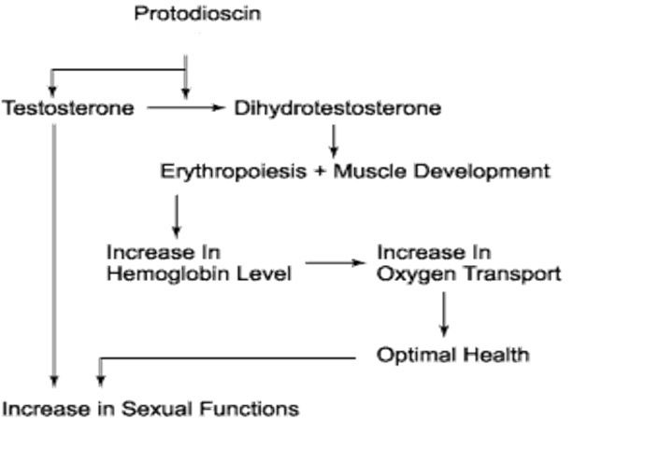
Reviewers Comment (2)

2. This study does not explain the study design or provide any basis for the number of subjects used. They could/should have considered a cross-over design. No power calculations for the number of individuals recruited for the study are provided.

Our Response: This is a preliminary validation study. Based on our preliminary in-house study, we conducted the present preliminary validation study to assess whether our protodioscin-enriched fenugreek seed extract can boost up the serum testosterone level in human volunteers (age: 43.08 + 7.35 years).

Successful completion of this study is now encouraging us to conduct the full blown placebo-controlled double-blind study in bigger population. Power calculation is required double blind, placebo-controlled clinical trial in bigger population. Kindly note that testosterone levels begin a natural decline as men reach 40+.

Reviewers Comment (3)

3. There is an inconsistency in the presentation of p-value in the conclusion sections (p=0.000***).

Our Response: A highly qualified statistician conducted all the statistical analyses, which are inserted in this manuscript.

Reviewers Comment (4)

4. The authors should justify why the enriched extract was not compared to fenugreek supplementation alone. This was an entirely necessary control group.

Our Response: We developed this novel fenugreek seed extract, which is enriched in 20% protodioscin, which is much more as compared to regular fenugreek seed extract. We conducted extensive in-house experiments to prove our hypothesis that this unique fenugreek seed extract enriched in 20% protodioscin is capable of boosting the free testosterone level significantly as compared to the regular fenugreek seed extract. As indicated earlier, this is a preliminary validation study.

I hope that the reviewers’ comments have been properly addressed and I am looking forward the revision of my revised manuscript

Sincerely

Debasis Bagchi, PhD, MACN, CNS, MAIChE

